iSupplier
Job Aid for the “PO Invoice Upload Process”

Requirements:

Information:
- Username
- Password

Key Software:
- Recommended browser: Internet Explorer
- Microsoft Excel

Change Record

Date | Version | Change Reference
28-Oct-2010 | 1.0 | No Previous document
29-OCT-2010 | 1.1 | DM feedback
23-MAY-2011 | 1.2 | Clarifications added per users
22-AUG-2011 | 1.3 | Clarifications added for new template
23-MAR-2012 | 1.4 | Clarifications added for the spreadsheet filename & reference to the External User Guide
9-APR-2019 | 1.5 | Updates to procedures for enhancements in the iSupplier application
4-APR-2020 | 1.6 | Removed SPI data

Procedure to submit the “PO Invoice Upload Process”
This procedure provides the functionally to upload a single invoice or multiple invoices at a time on one csv file in the iSupplier portal. In order to utilize this process you must have a user id with the assigned role for Invoice Entry.

The Invoice entry role allows access to purchase order, invoice and payment details. Includes abilities to create single invoices, upload multiple invoices, export PO data, & print and/or save a copy of PO’s. If you need to request or update your role, please submit a “User Setup Request Form” with all the required data and all users will be set up or updated within 1-2 business days.The form can be found in the iSupplier website at www.attpurchasing.com ; select the iSupplier link; then download the “User Setup Request Form”. Complete the form and indicate which role you would like. Only one can be chosen. Then email the form back to the iSupplier Helpdesk at g11041@att.com

Note: The PO Invoice Upload Process is recommended when uploading multiple invoices.

- Complete the “PO Invoice Upload Template” spreadsheet.
  - The spreadsheet can de downloaded from the AT&T Purchasing website at www.attpurchasing.com
  - Select the “iSupplier” link.
  - Select the “PO Invoice Upload Template” link from the “Forms and Templates” section
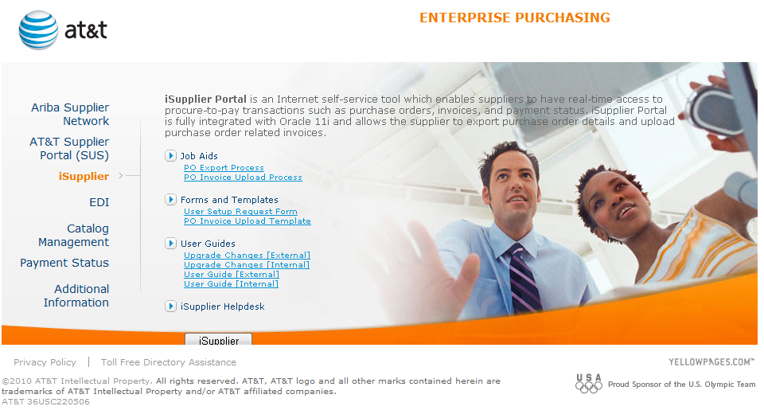
  - Save the file to a location on your computer

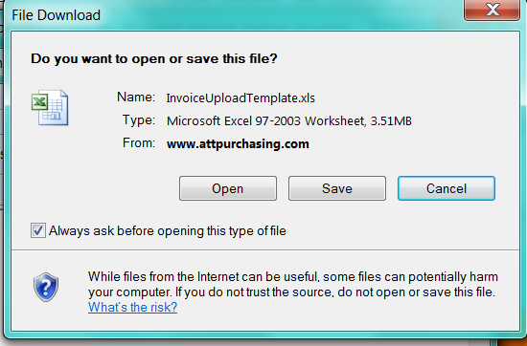

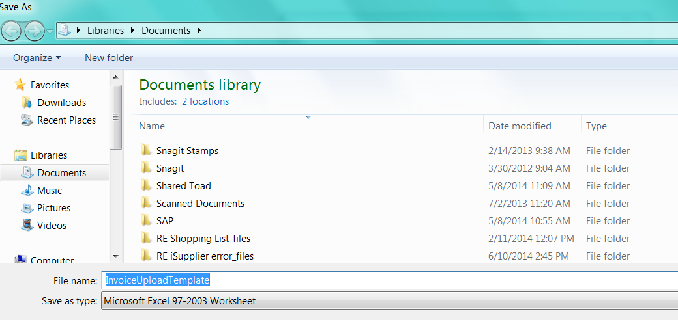

  - Open the file using Microsoft Excel. Select Enable Editing.
Populate the file following the general guidelines.
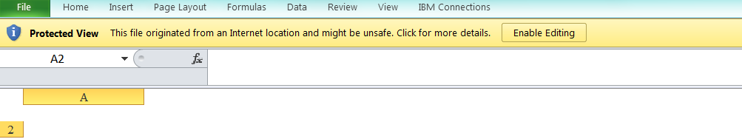

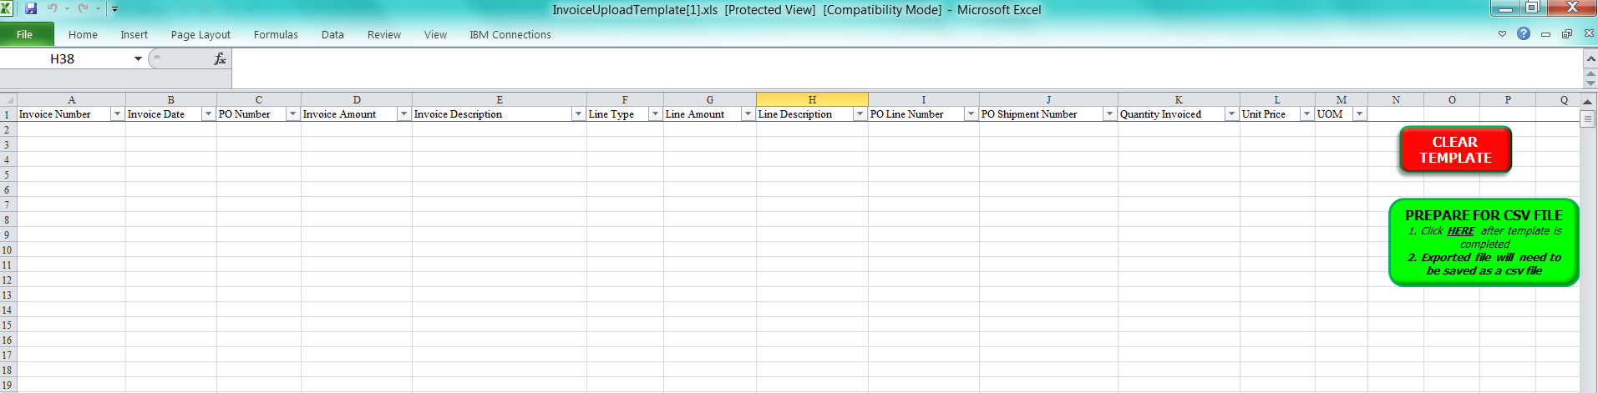
  - Populate the spreadsheet as follows (please refer to Appendix 1 for a sample):
    - General guidelines
      - Multiple invoices can be included in one spreadsheet.
      - Do not insert blank rows between invoices.
      - The spreadsheet template cannot be changed in any way. Example: Changing the column heading ‘PO Shipment Number’ to ‘PO Shipper Number’ or adding additional columns.
      - The spreadsheet filename should not include any spaces or special characters (including periods or underscores). Examples: Invoices10272010.csv
      - The green ‘Prepare for CSV file’ option must be selected after the template is completed.

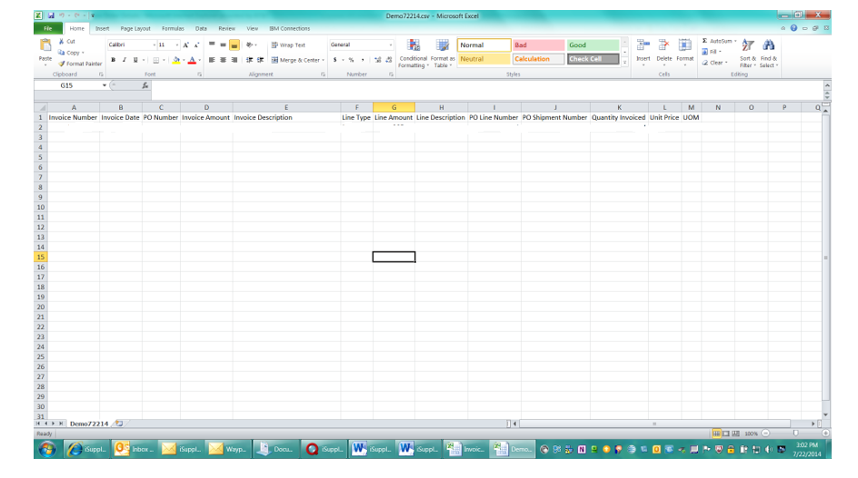

      - The spreadsheet should be saved as a .csv Comma Delimited file (make sure the extension type is lowercase).

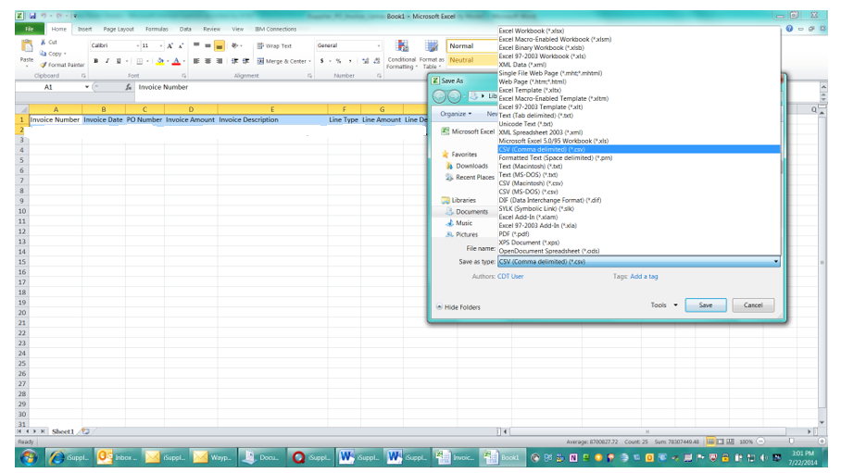
      - The red ‘Clear Template’ option needs to be utilized before creating a new spreadsheet upload to ensure that previously submitted data has been cleared.
    - Invoice Number
      - Must appear on every row associated with the invoice.
      - Must not use special characters.
      - Maximum 50 characters in length including spaces.
    - Invoice date
      - Use the format DD-MMM-YYYY for dates (example 20-OCT-2010).
      - Must appear on every row associated with the invoice.
    - PO Number
      - Purchase order associated with the invoice.
      - Only one purchase order per invoice.
      - Must appear on every row associated with the invoice.
    - Invoice Amount
      - Total of all invoice lines including tax and freight.
      - Must appear on every row associated with the invoice.
      - No commas or $ symbol.
    - Invoice description
      - Up to 240 characters; only the first 19 characters will print on paper checks.
      - Do not use special characters.
      - Must appear on every row associated with the invoice.
      - Must be the same for each line on an invoice
      - This field will auto populate with the invoice & PO number but can be overwritten if chosen.
    - Line Type
      - Valid values must be chosen or entered in all caps: ITEM, TAX, and FREIGHT.
      - Only one TAX and/or FREIGHT line per invoice.
    - Line Amount
      - No commas or $ symbol.
    - Line description
      - Optional for ITEM lines.
      - Required for TAX and FREIGHT line type.
      - Can be up to 80 characters in length.
    - PO Line Number
      - Required for ITEM line type.
      - Must match an existing PO line number.
      - Should be left blank for TAX or FREIGHT lines.
    - PO Shipment Number
      - Required for ITEM line type.
      - Must match an existing PO shipment number.
      - Should be left blank for TAX or FREIGHT lines.
    - Quantity Invoiced
      - Required for ITEM line type.
    - Unit Price
      - Required for ITEM line type.
      - Must match the unit price on the PO line indicated.
    - UOM
      - Valid values must be chosen or entered and is required for ITEM line type.
      - Must match the UOM value on the PO line.
      - Is case sensitive.

- Connect to this link via Internet Explorer:
https://purchasing.att.com

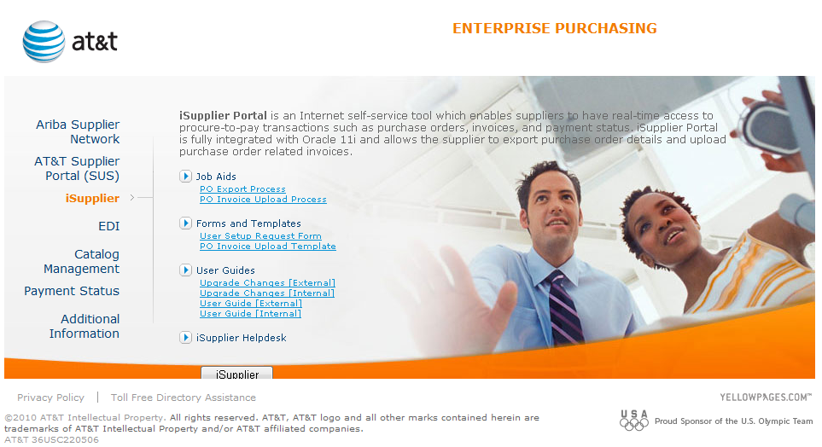
- Select to log into the application
- The iSupplier application page is displayed. Enter your user name and password then click

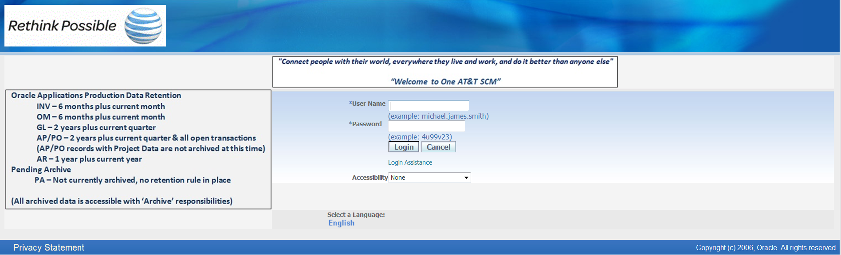
- Select the “ATT iSupplier Portal External User – Invoice Entry” responsibility from the Navigator screen (if needed)
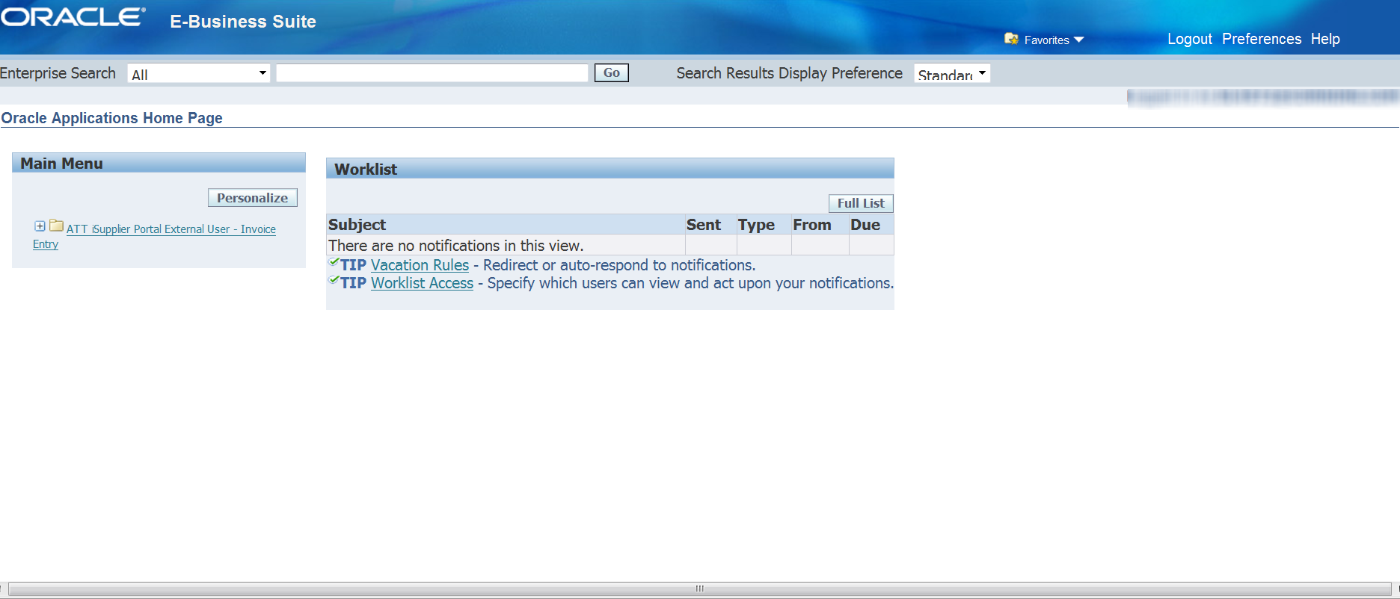
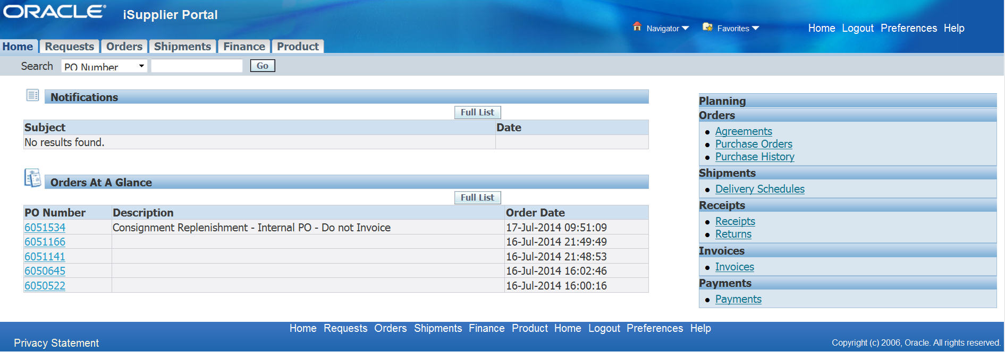
- Select the “Finance” tab from the Home page.

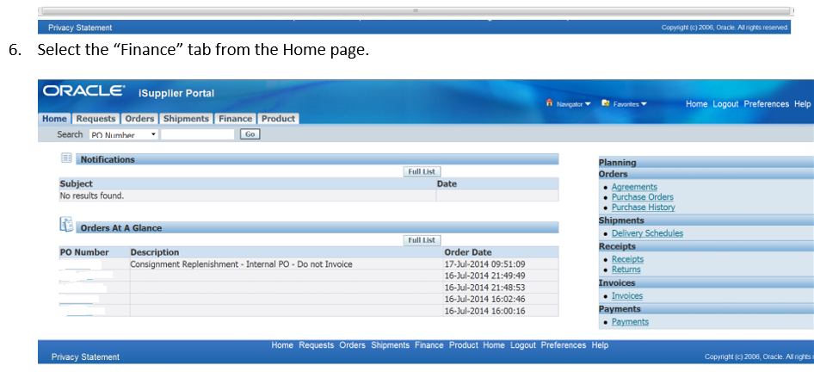

- Select the “Invoices Upload” option from the blue menu bar.
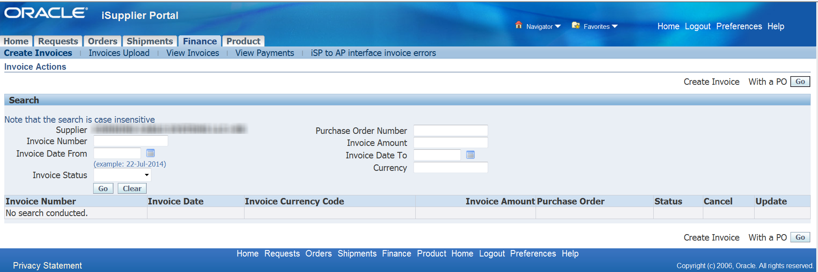

- Select the “BROWSE” button next to the “Invoice File” field and navigate to the location where the Invoice Upload spreadsheet is located on your PC and select the appropriate file.

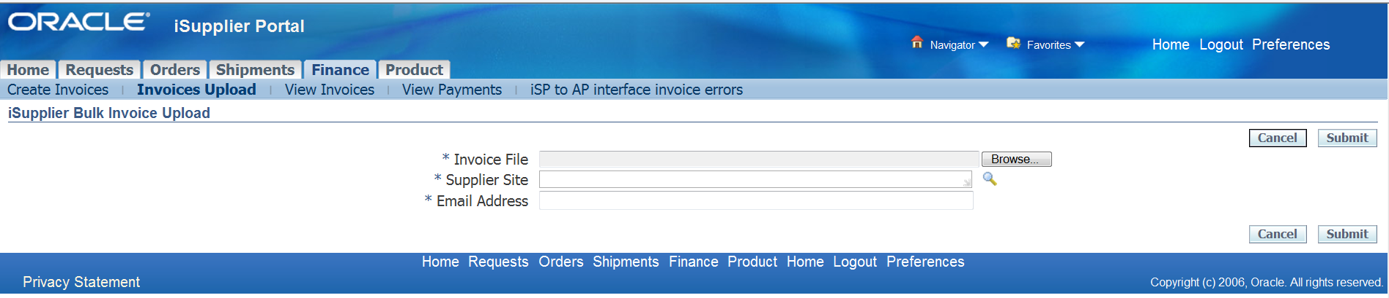
- Select the “FLASHLIGHT” icon next to the “Supplier Site” field.
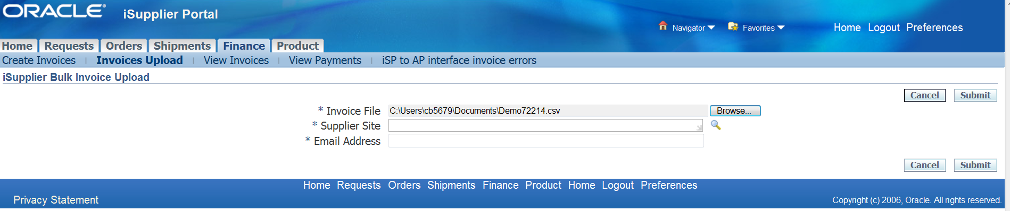
- Then click the ‘Go’ button.
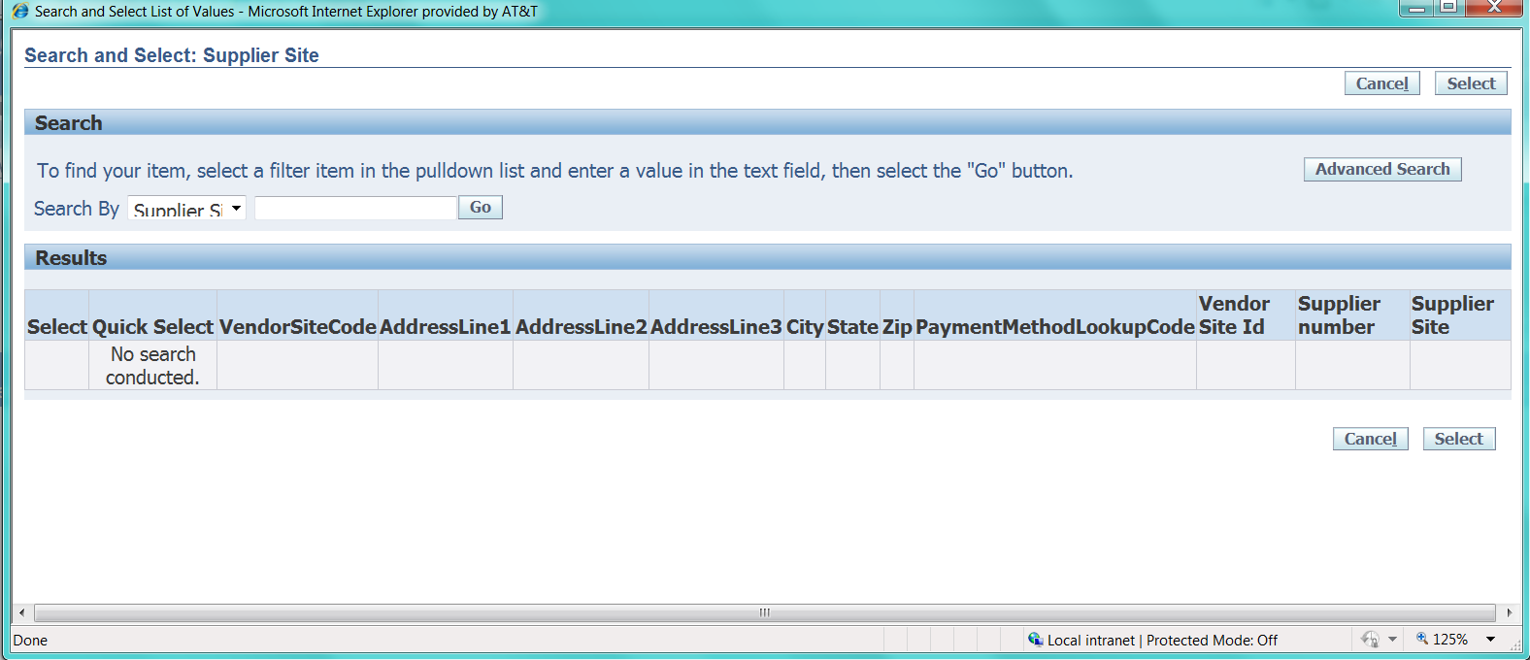

- A list of valid pay sites for your supplier will appear. Please select one by clicking the ‘Quick Select” icon in the appropriate row.
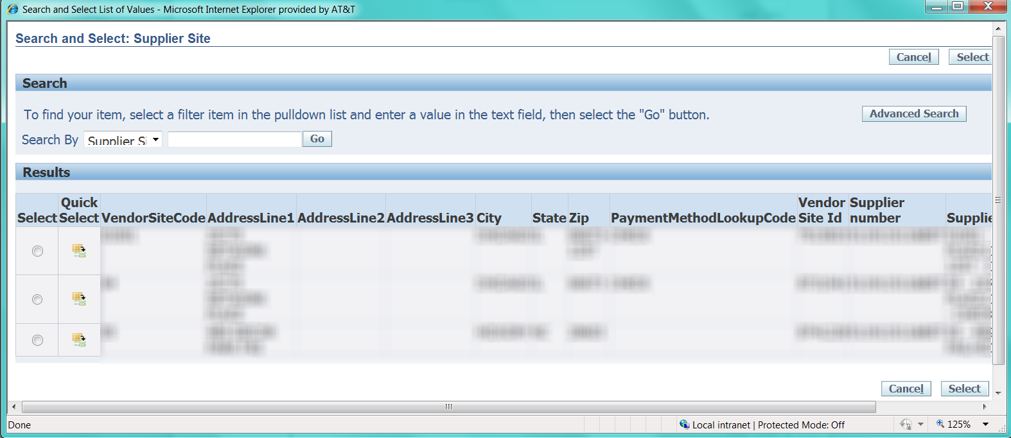
- Enter an email address. The ‘Custom iSupplier Invoice Upload Report’ that corresponds to the csv file that you submitted will be sent to the email addresses that are listed in the email address field(Multiple email addresses can be entered; please separate them using a semi-colon and a space.

The ‘Custom iSupplier Invoice Upload Report’ must be reviewed as will provide the invoice status after the iSupplier validations have been applied against them .There are only 2 statuses which are provided by the iSupplier validation program.
  - Invoices Successfully Accepted - this means that all the data entered on the csv file has passed the required iSupplier validations and can be sent to AP so that further validations can be performed and payment can be issued.
  - Invoices Not Accepted - this means that the iSupplier validation program has found errors on the data that was entered on the csv file. An error description as well as the corresponding PO line details will be provided so that you can correct the csv file and resubmit for validation. You will need to continue to make the necessary corrections until you the report shows that the “Invoices Successfully Accepted’.

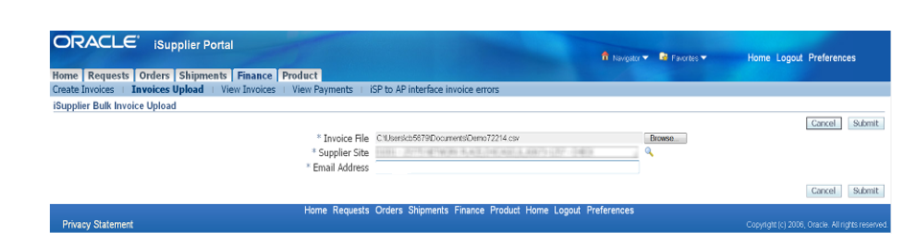
- Select the ‘SUBMIT’ button to upload the spreadsheet.

- The system will display various requests while the process is running. Use the ‘REFRESH’ button above the status field (not the Internet Explorer Refresh) to update the status and view the progress of your request.
  - The column labeled ‘PHASE’ reflects the status of the request. It should change from ‘Pending’ to ‘Running’ then to ‘Completed’.
  - Additional requests may appear as the request progresses through processing.
  - Please wait until the ‘PHASE’ for all requests changes to ‘Completed’

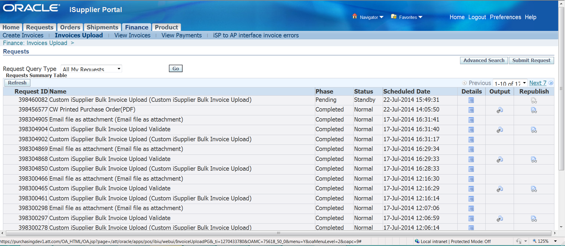.
Status of Running Displayed after clicking on Refresh
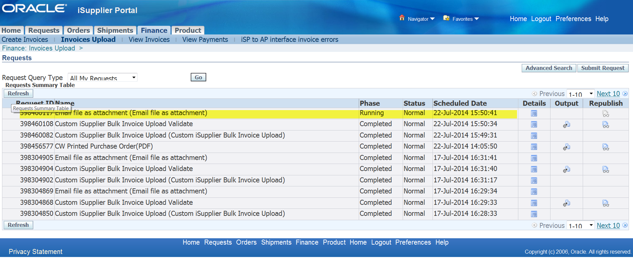

Status of Completed Displayed after clicking on Refresh:
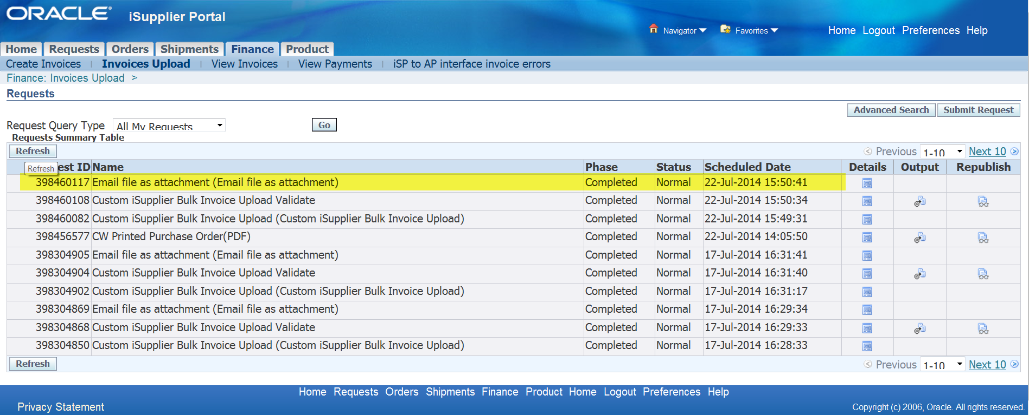

Note: You can view the ‘Custom iSupplier Invoice Upload Report’ by clicking on the output button (on the right)
- The system will automatically generate one or several email reports based on the results of the validation process.
  - In order for the data to in the reports to display properly, please open the report using MS Word or WordPad. You may need to save the attachment to a location on your desktop before opening the report.
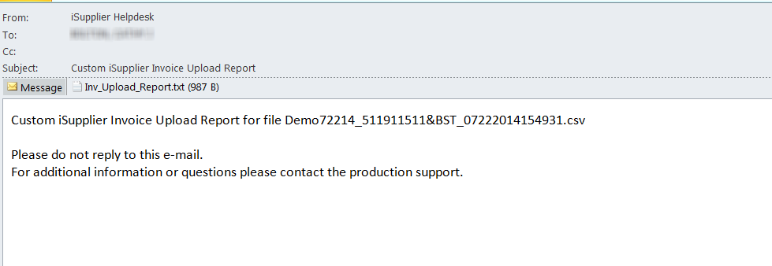
An alternate Method for opening the Inv_Uplaod Report to Click on the Attached Report

Selection Options are displayed
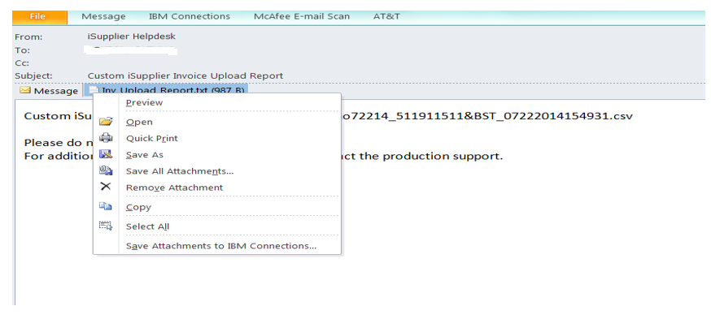
Select Preview Option then select 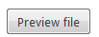
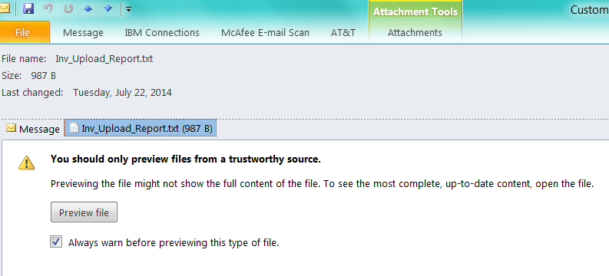
Report is displayed
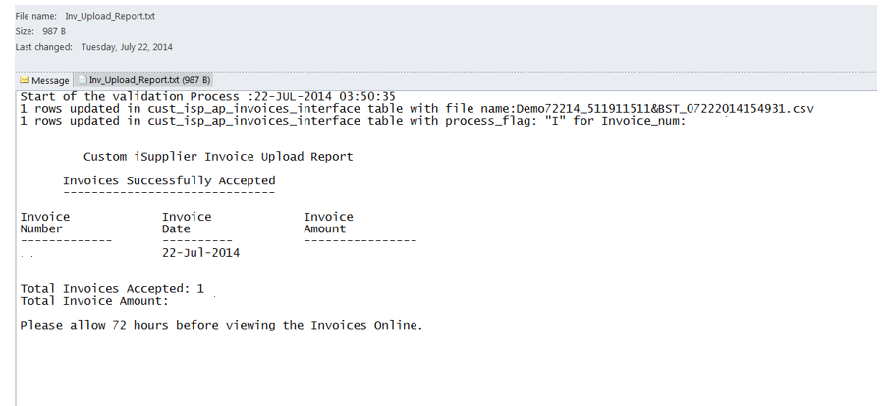

  - The report(s) will provide a list of invoices successfully processed and may also include a list of errors identified during the validation process.
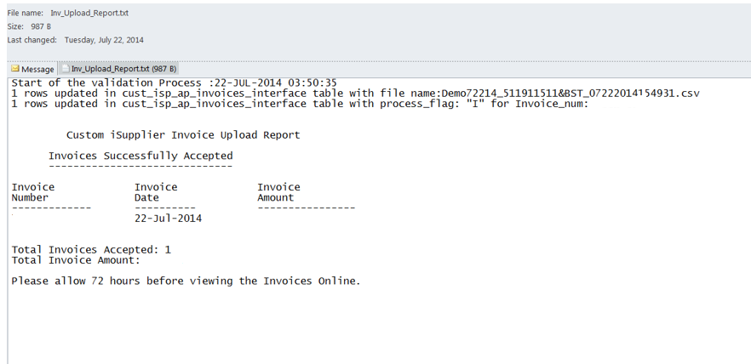
  - Rejected invoices should be corrected and resubmitted in a new file.
  - Accepted invoices should not be resubmitted in subsequent invoice uploads.

- Please allow 72 hours before attempting to view the accepted invoices online.
  - “Accepted” invoices uploaded via this process require additional processing by our Accounts Payable system and may not be approved for payment if other errors are identified.

Contacts

iSupplier Helpdesk

Please contact the iSupplier Helpdesk via email at g11041@att.com if you need additional information or need assistance.

Job Aids /Downloads

http://www.attpurchasing.com/ under the iSupplier Section

Please review and reference the ‘External User Guide’

Invoice and Payment Questions

Questions regarding invoice payment and hold resolution for Oracle related POs should be directed as follows:
Mobility PO related invoices (Billing address: PO Box 66786), contact G07382@att.com
Wireline PO related invoices (Billing address: PO Box 66785), contact G14385@att.com
IMPORTANT: Inquiries for multiple late invoices (5 or more) must be submitted in MS EXCEL format including invoice #, Date and Purchase order number and additional notes questions remaining based on iSupplier research. PDF statements will be returned with these instructions.

Supplier set-up, supplier/site maintenance, or remit to information
If you have questions concerning supplier set-up, supplier/site maintenance, or remit to information, please contact the Vendor Management team at venmtce@att.com for assistance.

Invoice Upload Validation Errors
Listed below are the errors that may occur during the validation process
Invoice Number has variable descriptions
Release Number cannot be null for Blanket PO in Invoice
Invoice Number can not be null
Invoice Number can only be alphanumeric. No special characters
Invoice Number should not be more than 50 characters
Duplicate Invoice Number
Invoice Date can not be null
Invoice Date ' 18-07-2014 ' should be in valid date format (DD-MON-YYYY)
PO Number can not be null
PO Number is not valid
PO Number is not valid for this supplier
PO Number '12345 ' is not Approved
PO Number '12345' is Cancelled
PO Number '12345' is Closed
PO Number '12345' has an End Date
One Invoice cannot have multiple Release Numbers
One Invoice cannot have multiple PO Numbers
Invoice Amount "99.x" should be a number
Invoice Amount '99.9998' cannot have more than 2 decimals
Invoice_amount can not be null or negative'
Invoice Amount ' 123.88' does match with the total of Line Amount(s) for this Invoice
Invoice Description should not be more than 240 characters
Invoice should have at least one line with Line Type = "ITEM"
Invoice should only have one TAX line
Invoice should only have one FREIGHT
Release number for the standard PO Number has to be null
Release number for the Blanket PO Number cannot be null
Release number is not valid for the PO Number
Release number is not Approved
Release number is Cancelled
Release number is Closed
PO Line Number should not be null for Line Type = "ITEM"
PO Line Number is not valid
PO Line Number is Cancelled
PO Line Number is Closed
UOM should not be null for Line Type = "ITEM"
UOM is not valid
Line Type 'PARTS' is not valid. It can only be "ITEM", "TAX", "FREIGHT"
Line Amount cannot be null
Line Amount cannot be zero
Line Amount '99.x' should be a number
Invoice unit price does not match to the purchase order unit price
Line Amount '99.9997' cannot have more than 2 decimals
Line Description should not be more than 240 characters
PO Shipment Number cannot be null
PO Shipment Number is not valid

Invoice Upload Validation Errors

PO Shipment Number is Cancelled
PO Shipment Number is Closed
Quantity Invoiced should not be null for Line Type = "ITEM"
Quantity Invoiced '9x' should be a number
Quantity billed exceeds quantity ordered
Quantity Invoiced '99.99987' cannot have more than 2 decimals
Unit Price should not be null for Line Type = "ITEM"
Unit Price '99.x' should be a number
Unit Price * Quantity should equal Line Amount
Sum of the Item Line Amount should not be Zero

Appendix 1 - Sample Invoice Upload Report

