
iSupplier
Job Aid for “Create Invoice ”

Change Record

Date | Version | Change Reference
07/21/2014 | 1.0 | New Document
07/23/2014 | 1.1 | Content Updates
04/14/2020 | 1.2 | Removed SPI data

Contents
Procedure to “Create Invoice” 4
Accessing iSupplier 4
Create Invoice 6
Saved Invoices 16
Contacts 19
iSupplier Helpdesk 19
Job Aids /Downloads 19
Invoice and Payment Questions 19
Supplier set-up, supplier/site maintenance, or remit to information 19
Create Invoice Validation Errors 20

Procedure to “Create Invoice”
This procedure provides the functionally to create a single invoice at a time using the iSupplier portal. In order to utilize this process you must have a user id with the assigned role for Invoice Entry.

The Invoice entry role allows access to purchase order, invoice and payment details. Includes abilities to create single invoices, upload multiple invoices, export PO data, & print and/or save a copy of PO’s. If you need to request or update your role, please submit a “User Setup Request Form” with all the required data and all users will be set up or updated within 1-2 business days.The form can be found in the iSupplier website at www.attpurchasing.com ; select the iSupplier link; then download the “User Setup Request Form”. Complete the form and indicate which role you would like. Only one can be chosen. Then email the form back to the iSupplier Helpdesk (g11041@att.com).

Note: The PO Invoice Upload Process is recommended when uploading multiple invoices.

Accessing iSupplier
- Navigate to http://www.attpurchasing.com/
- Select the iSupplier Section
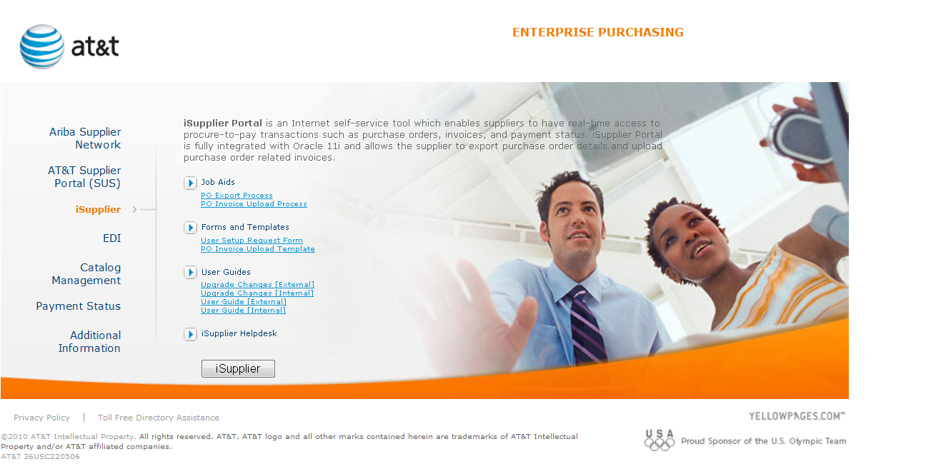
- Select to log into the application
Or you can click on the url for the iSupplier application:
https://purchasing.att.com/OA_HTML/RF.jsp?function_id=31116&resp_id=-1&resp_appl_id=-1&security_group_id=0&lang_code=US&params=5j0bzUgs9j2gsy7f2IhOgr-7x5nWRx63YDVSeM1o2-M

- The iSupplier application page is displayed. Enter your user name and password then click

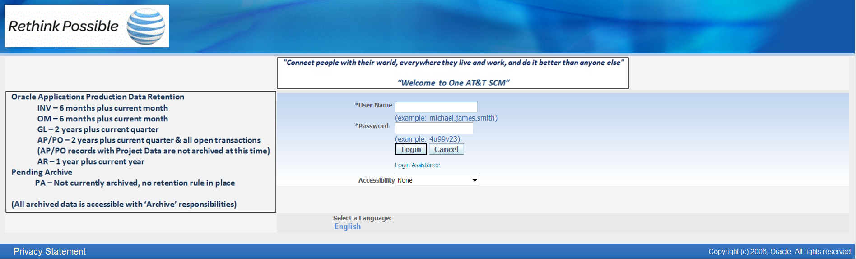

- If you need to reset your password, .please click on the “Login Assistance” link on the iSupplier login screen, Enter your username, and you will receive an email with a link for resetting your password. When you receive the email, click on the “reset password” link and follow the onscreen prompts.
To ensure that you receive the password reset emails, please add ERPPRODwfmail@maillennium.att.com to your safe receiver list.

Create Invoice
- Determine the Purchase Order to be invoice then select the Finance Tab

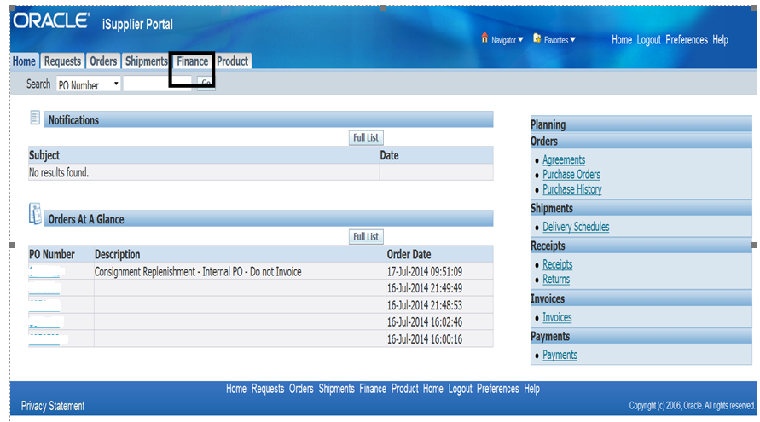
- The Screen Defaults to the Create Invoice Option. Select

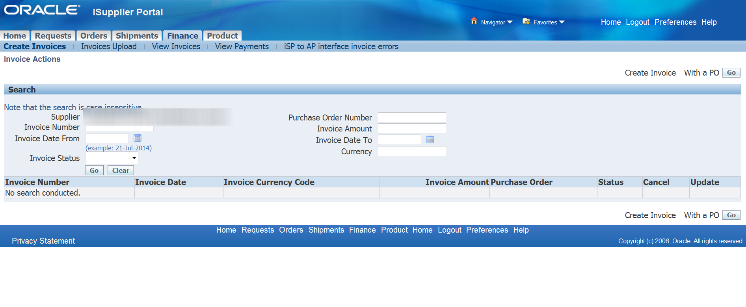

- Step 1 - Purchase Order : Enter Purchase Order Number to be invoiced–then select

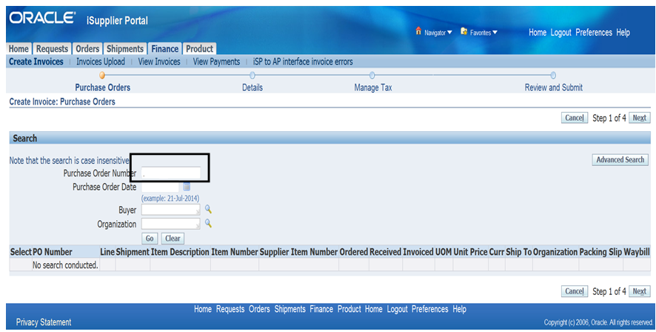

- Purchase order is located and displayed

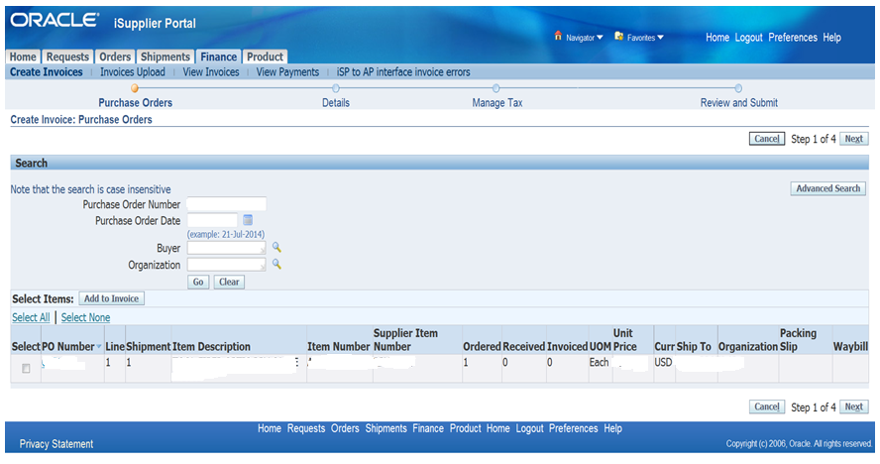

- Click in the Select Box then select 
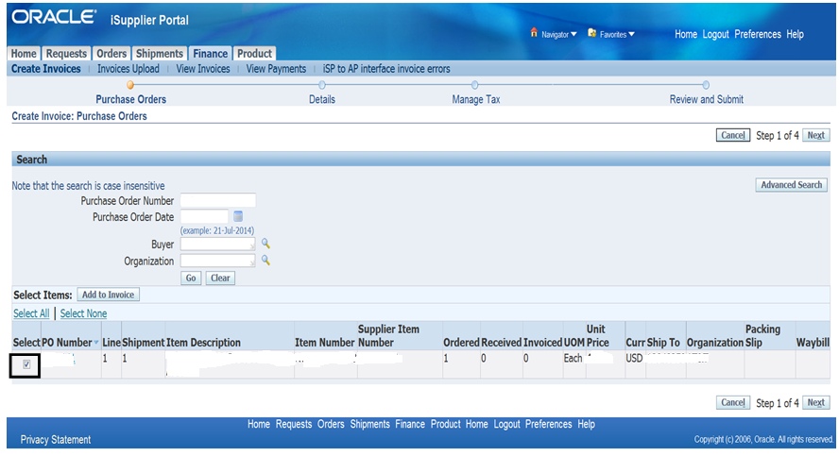

- Step 2 – Details Screen is displayed

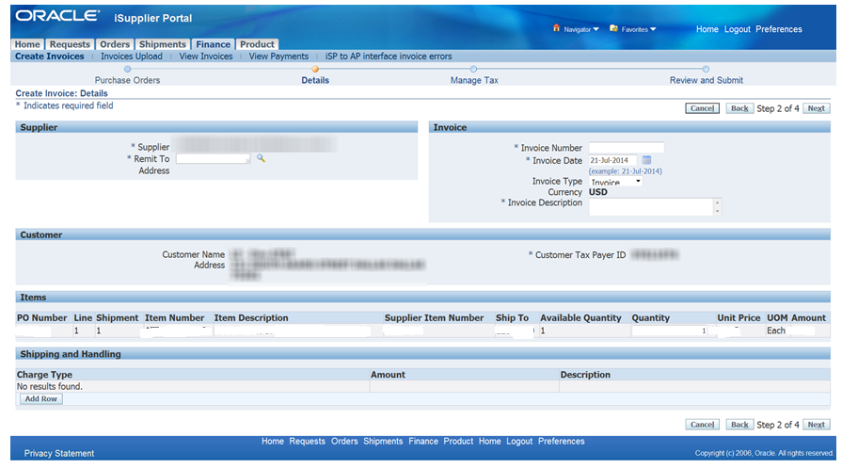

- Update Supplier Section with Remit to Information. Click on

Note: The Remit to field will auto populate if the supplier only has one Remit To option in the system. Only Active Remit To sites are displayed. If your desired Remit To site is not displayed or the Remit To information is incorrect then please contact the Vendor Management team at venmtce@att.com for assistance

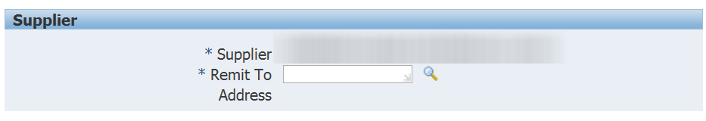
- Search and Select Remit to screen is displayed. Click on

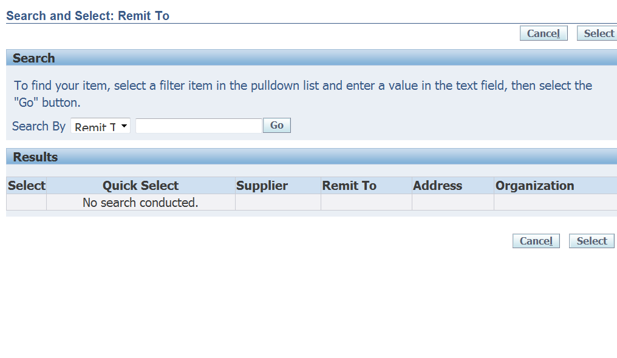
- Remit to Options are displayed. Click on the 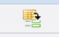 or Select then
to populate the Remit To Information.
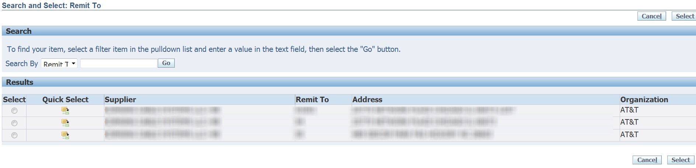
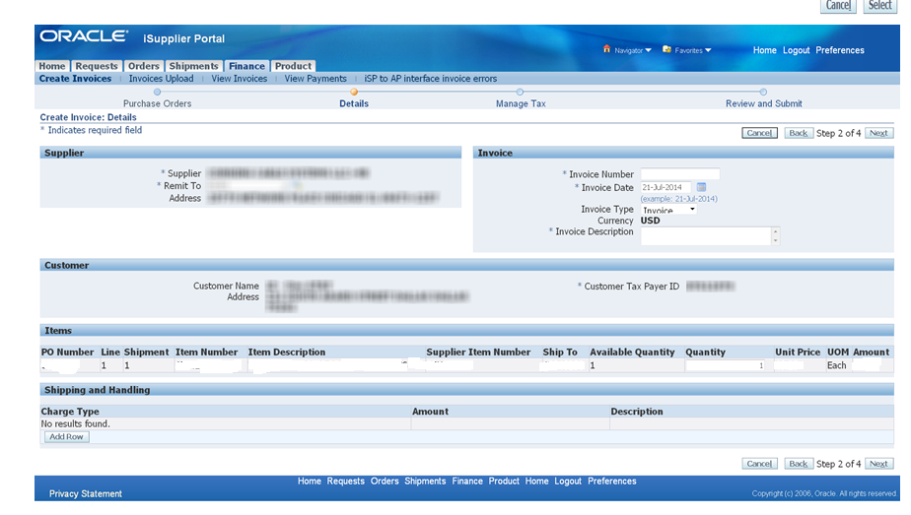

- Update the Invoice Section with Invoice Number, Invoice Date, and Invoice Description

Note: The iSupplier Create Invoice option only allows the creation of invoices. Submission of a Credit Memo must be sent to Accounts Payable for manual processing.

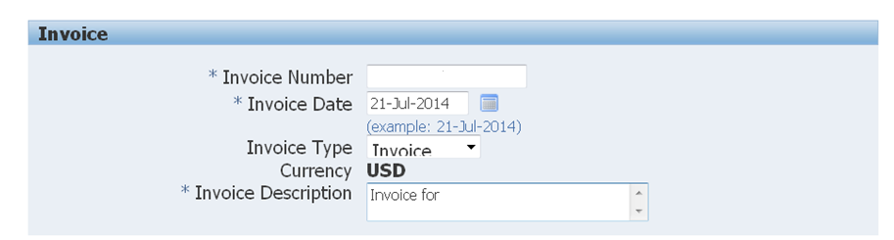

Invoice Number Requirements:
      - Must not use special characters.
      - Maximum 50 characters in length including spaces
      - Unique Number. Invoice Numbers may not be reused one entered into iSupplier application.

Invoice description Requirements:
      - Up to 240 characters; only the first 19 characters will print on paper checks.
      - Do not use special characters.

Invoice Date Requirements:
- Format dd-MMM-yyyy

- Update the Item Section with the quantity to be billed. The unit price defaults from the purchase order information.

Note: Quantity for Services are able to be entered in fractional amounts (i.e., 1.5, .5). However, Quantity for Goods must be entered in whole amounts (i.e. 1, 22, and 100)

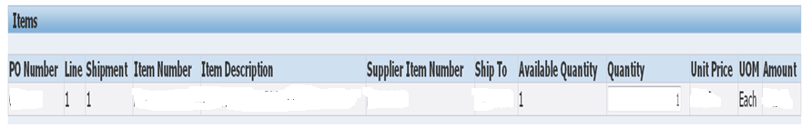

- Shipping and Handling Section.

This section allows the inserting of rows for charges for Freight and Tax. The system limits the billing of one Freight and Tax Line for the invoice. To insert a row Click on  and select the charge type from the pull down menu
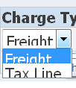

Note: Freight and Tax validations occur after the submission of the Invoice to Accounts Payable. Improper charges may generate an Invoice Hold. Please Contact Accounts Payable for assistance.

- After the lines are inserted into the section, update the Amount.

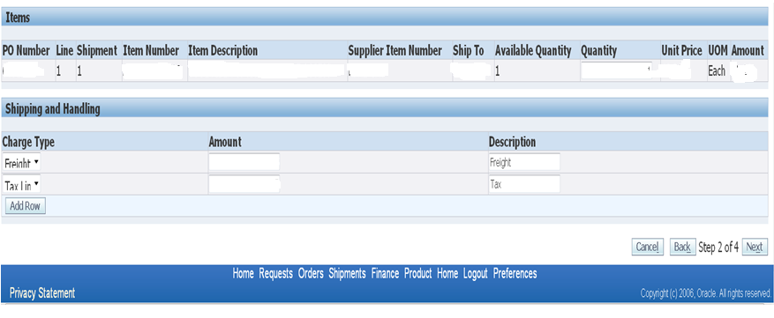

- Click on to advance to Step 3 – Manage Tax

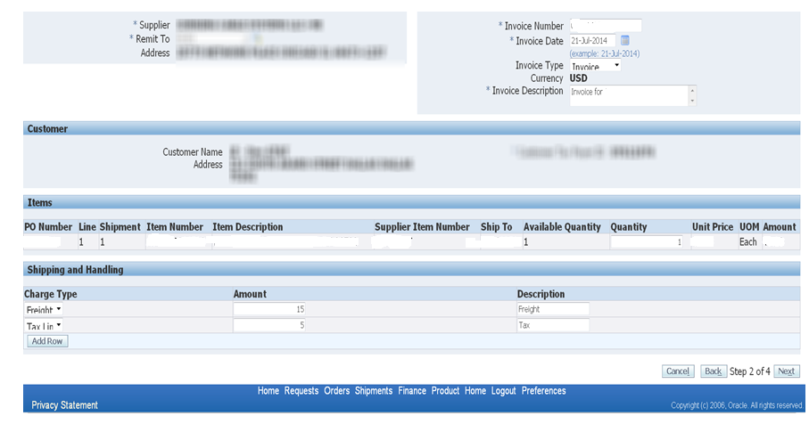

- Screen displays Invoice including Invoice Summary of all charges.

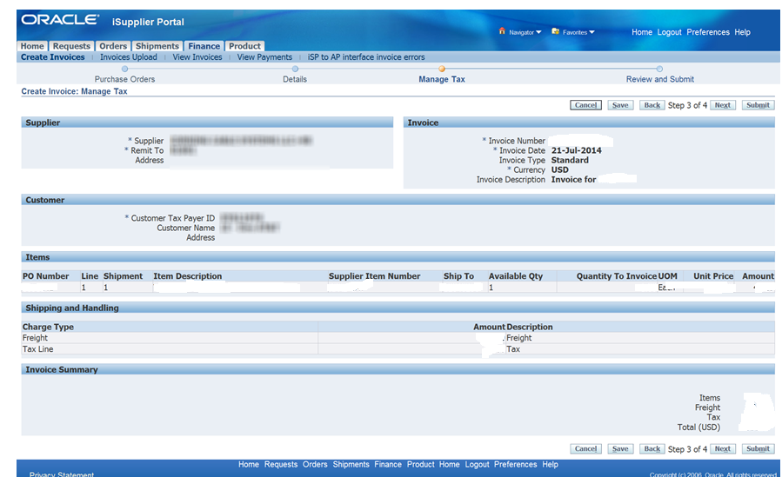

- Click on  to advance to Step 4 – Review and Submit

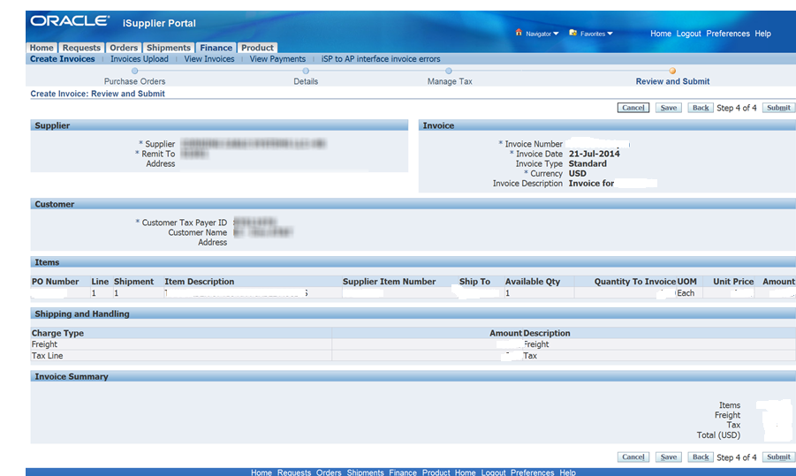
- Click on to complete the process

- Confirmation message is displayed. This is the only notification generated upon submission of the invoice.

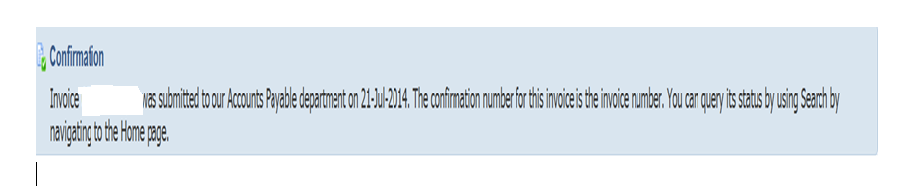

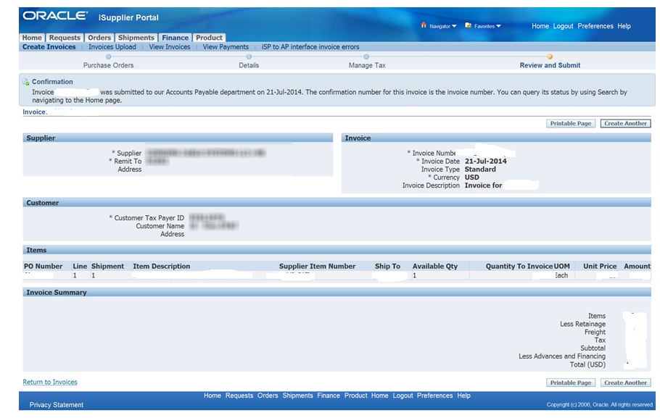

- The Screen provides the option to display a . Once displayed you will need to utilize your browser printing options to print the page.

- The screen provides the opton to  Invoice or 

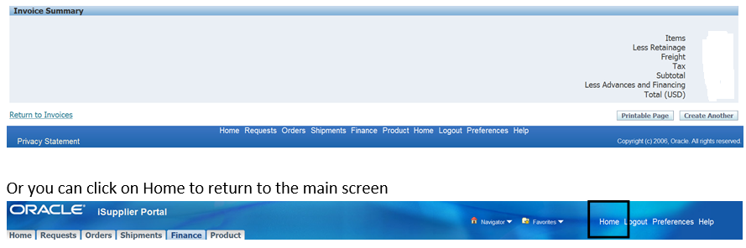

Saved Invoices
- Upon researching Step 3 - Manage Tax the system provides the option to save the invoice.
The Save option provides the ability to save the invoice and return at a later time to complete the create invoice process.

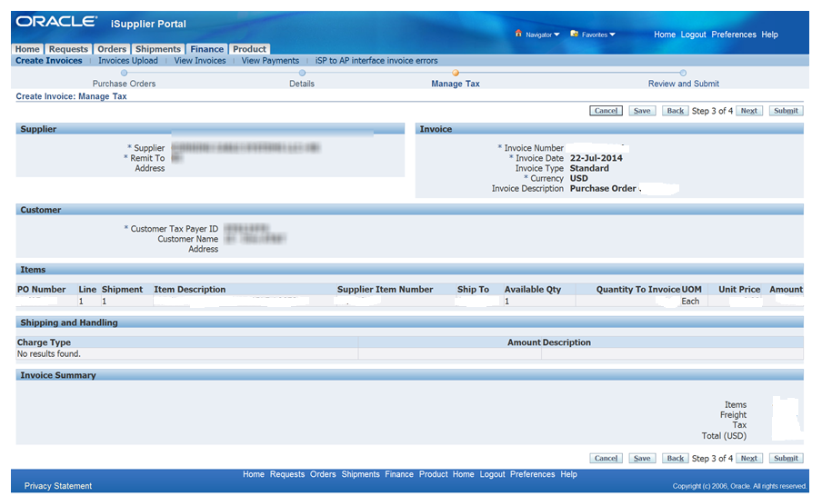

- Click on . The system will display a confirmation that the invoice has been saved for update and later submission.
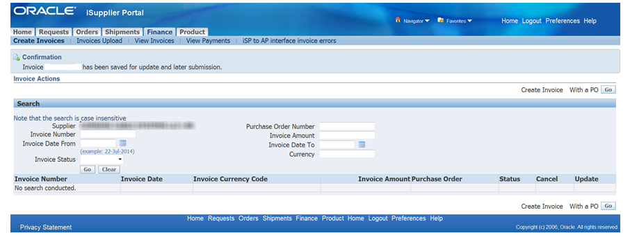
- To resume work on saved invoice. Click on the Finance Tab then select Create Invoice.

- Update the Invoice Number field with the saved invoice number
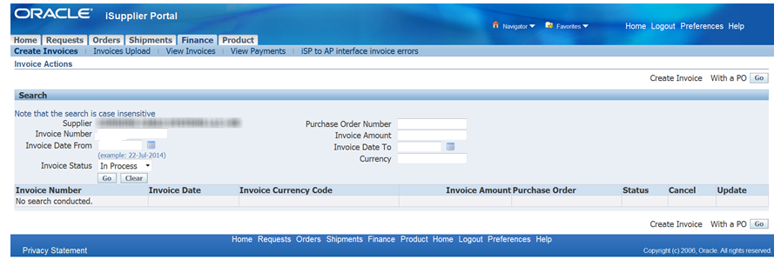

Select Invoice Status of “Unsubmitted” from the pull down menu then select
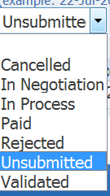

- The invoice search results are displayed.
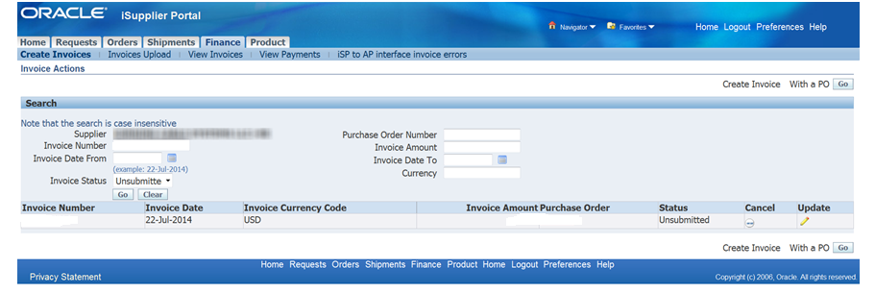

- Select  to reactivatethe invoice and complete the Create Invoice Process or Select to cancel the Create Invoice Process.

- If you select to Update option then the system will take you back to Step 2 –Details. You will be able to complete the steps to submit the invoice.

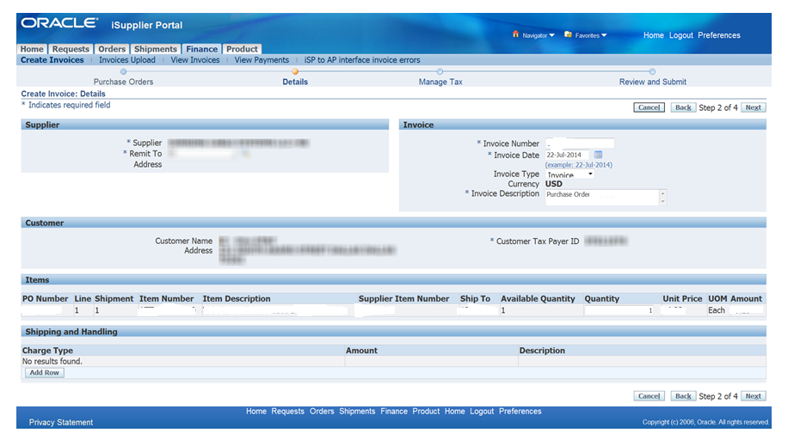

Contacts

iSupplier Helpdesk

Please contact the iSupplier Helpdesk via email at g11041@att.com if you need additional information or need assistance.

Job Aids /Downloads

http://www.attpurchasing.com/ under the iSupplier Section

Invoice and Payment Questions
Questions regarding invoice payment and hold resolution for Oracle related POs should be directed as follows:
Mobility PO related invoices (Billing address: PO Box 66786), contact G07382@att.com
Wireline PO related invoices (Billing address: PO Box 66785), contact G14385@att.com
IMPORTANT: Inquiries for multiple late invoices (5 or more) must be submitted in MS EXCEL format including invoice #, Date and Purchase order number and additional notes questions remaining based on iSupplier research. PDF statements will be returned with these instructions.

Supplier set-up, supplier/site maintenance, or remit to information
If you have questions concerning supplier set-up, supplier/site maintenance, or remit to information, please contact the Vendor Management team at venmtce@att.com for assistance.

Create Invoice Validation Errors
Listed below are the errors that may occur during the validation process.
- A value must be entered for "Invoice Number"
- A value must be entered for "Invoice Date"
- A value must be entered for "Invoice Description"
- A value must be entered for "Quantity"
- Value "x" in "Quantity" is not a number
- Invoice Number can only be alphanumeric. No special characters
- Row 1 Quantity - You can not increase the Quantity to Invoice amount above the available ordered quantity.
- Value "18-XXX-2014" in "Invoice Date" is not a date formatted as "dd-MMM-yyyy"
- A value must be entered for "Remit To"
- The Invoice Number you have entered already exists. Please enter a unique Invoice Number
- Quantities and amounts on a Standard invoice cannot be negative. Please reenter
- Invoice Type must be equal to Invoice
- Only one Freight line per invoice allowed
- Only one Tax line per invoice allowed
- Line Amount cannot be zero
- Quantity must be a whole number for Goods based invoice lines

