iSupplier
Job Aid for
“Consignment inquiry”

iSupplier Consignment Inquiry Screens
Log on using the “ATT iSupplier Portal External User – Invoice Entry” responsibility
- Select the “Product” tab
- Click on the “Consigned Inventory” menu link
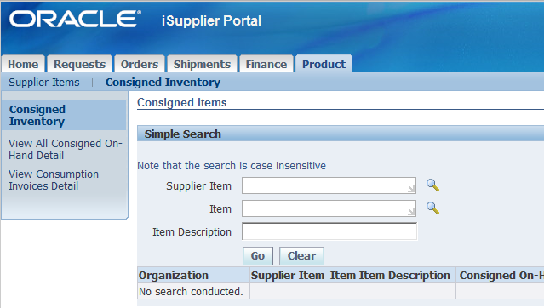

- Enter your item search criteria (e.g. ATT Item Number in the Item field) and hit the Go Button
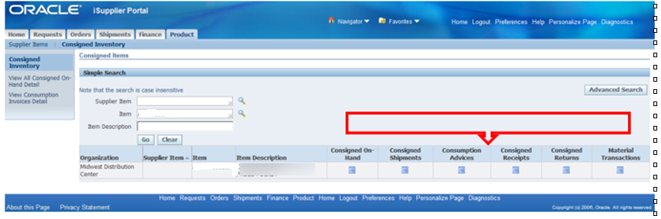
- Click one of the 6 icons to the right of your result to view that type of data

- Consigned On-Hand – This shows the on-hand balances for the consigned item and shows the user with a * which stock is AT&T Owned (select ‘export’ button to download data)
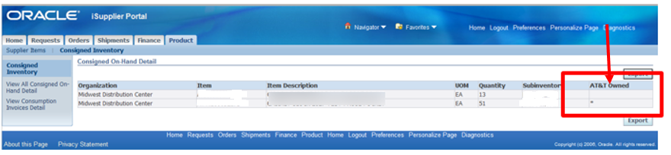

- Consigned Shipments – This shows the Consignment POs (aka “Receipt Only” POs) for an item. The Supplier Reference column is the ref number passed to us via EDI / PO Upload process. This informs AT&T what product will be sent to a particular DC.
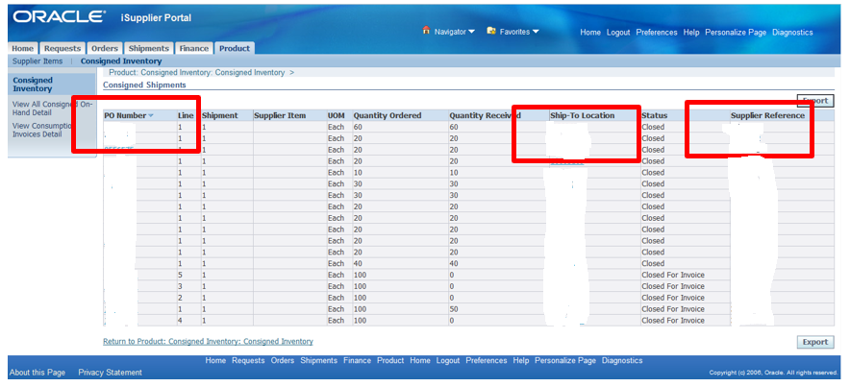

‘Closed for invoice’ indicates that this is not a PO to be invoiced; it is used so the warehouse can receive/receipt goods

- Consumption Advices – Shows the Consumption POs (Invoice Only PO) created automatically as a result of the “Transfer to Regular” transaction when AT&T takes ownership of the inventory.
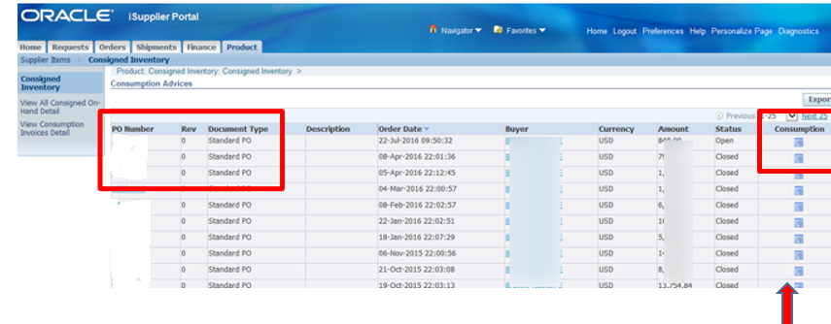

Consumption icon – This shows the transaction in the warehouse and details when the change of ownership took place.
Status of ‘open’ indicates it has not been paid

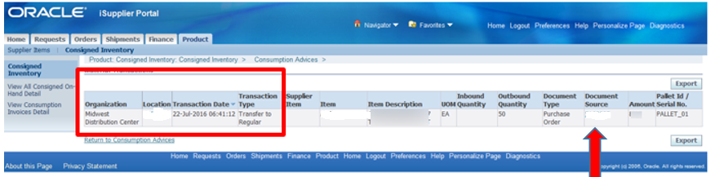
‘Document source’ # is the BPA/contact #; click on this link to display the invoice only PO
- Consigned Receipts – This shows the receipt of goods in a DC against the Consignment POs. Pallet IDs/Serial Number are shown if available.
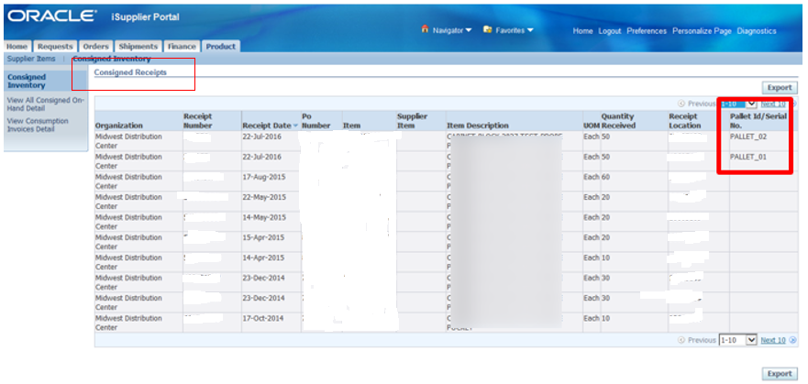

- Consigned Returns – This shows returned receipt transactions for Consignment POs
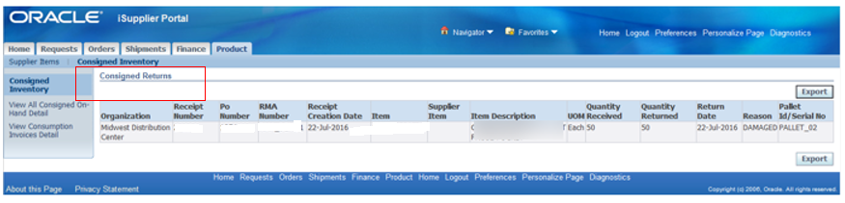

- Material Transactions – Shows Receipts, Returns and Transfer to Regular transactions
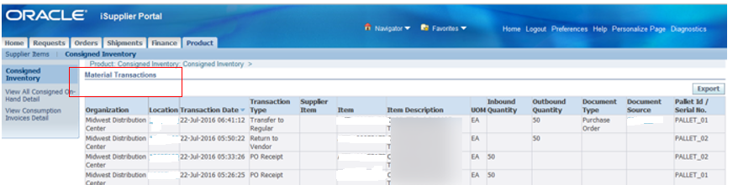
- On the left of the screen are 2 additional inquiry screens:

- View All Consigned On-Hand Detail – Shows On-Hand data for all consigned items for that supplier. User can Export the data as a csv file by clicking the Export button
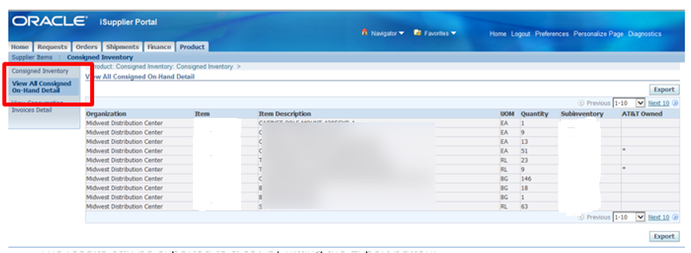
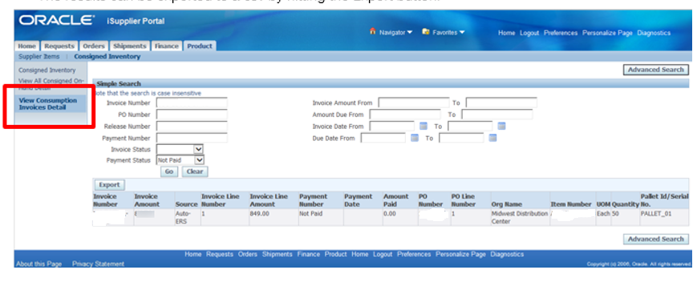

Contact the iSupplier Helpdesk via email at g11041@att.com if you need additional information or need assistance.

