iSupplier
Job Aid for
“View Advance Ship Notice (ASN) ”

Procedure to “View Advanced Shipment Notice (ASN)”
ASN data is a critical component for supply chain efficiency; without it, scanning, receipting, and validating the contents of a shipment to a warehouse may be delayed or even rejected. Additionally, ASN data provides interested parties the ability to view a ‘promised by’ date to anticipate the arrival of an order at the warehouse. Authorized suppliers or VARs (value added resellers) can create or upload a template in iSupplier which provides pertinent shipment and item detail information.
If you have not yet registered for access to iSupplier, follow these instructions:
Go to the website: http://www.attpurchasing.com.
“iSupplier” (left column) should be highlighted
Select the ‘User Setup Request Form’ and complete the required fields and submit
An email notification will subsequently be sent to you, providing your ‘user name’ and ‘password’ values to log into iSupplier. Contact the iSupplier Helpdesk at g11041@att.com with any questions.

- Log in to iSupplier
- Click on ‘Shipments’ tab, then ‘View Advanced Shipment Notices’
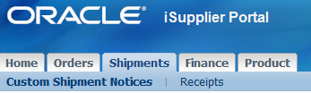

- 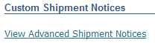

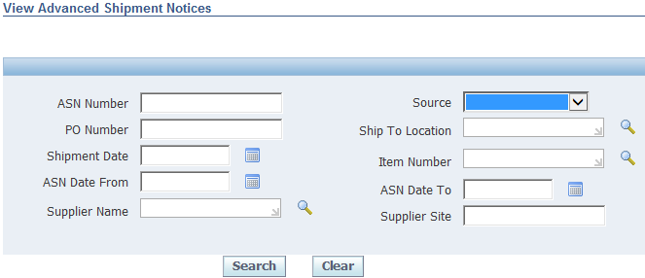

- Narrow your results by entering a value in at least one of these fields & “Search”:
- ASN #
- PO #
- To/from date range
- Supplier site
- Source (drop down menu): ‘EDI856’, ‘ISP_ASN_FORM’, ‘ISP_ASN_UPLOAD’, or blank
(EDI856 = transmitted via EDI; ISP_ASN_FORM = ASN is created online within iSupplier; ISP_ASN_UPLOAD = ASN is submitted via the template upload process)
- A ‘blind’ search can be done, by leaving all the fields blank followed by ‘search’ (in which case, 30 days’ data will be shown, as below); however, the response time may be prolonged.
- Supplier name (this option is limited to AT&T employees only)

“Blind” search result:
Vendors/Suppliers will only see ASN data that is associated with their company; AT&T employees can view data from all vendors if a specific vendor is not selected.
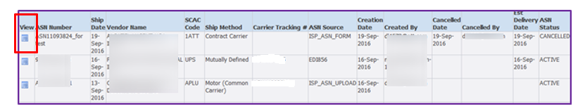
- Select the ‘view’ box to see ASN details (defaults to ‘shipment lines’ tab):
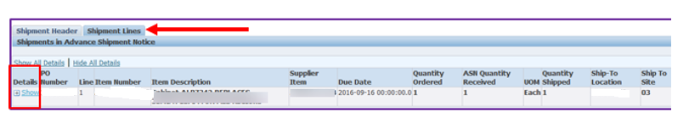
Click on ‘Show’ link or the + sign on a row (or ‘show all details’) to view line item details:
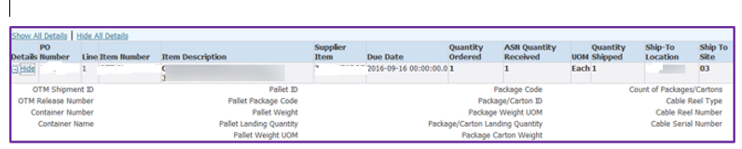

- Select the ‘shipment header’ tab to ‘general’ shipment information about the order:
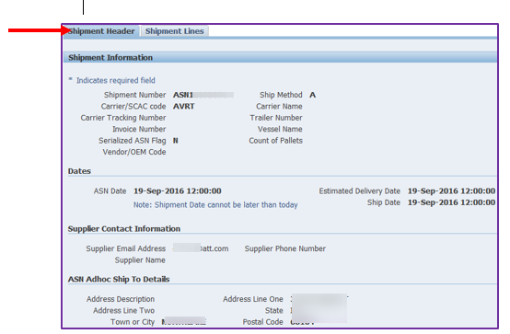

- If the ASN contains serialized data, it will be seen to the right of the ‘ship to location’ & ‘ship to site’ fields (as seen on previous page, under ‘shipment lines’ detail):
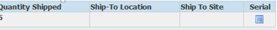

Select ‘serial’ box to view:
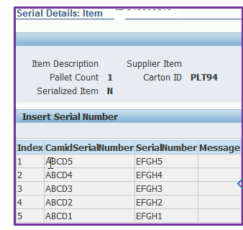
Note: additional serial types will be visible (such as MAC IDs) which are not captured here

(e.g., 1 Purchase Order, with 1 item: ATT.*********, quantity: 5 units)
“Go Back” to previous page
“Home” to initial page of “view advanced shipment notices”
“Export”: ‘save’/’save as’ defaults to .csv format; to save in excel format: In excel: File > Open > Select the saved CSV file > Select ‘all files’ (*.*) > Open > Text Import Wizard box > click ‘delimited’ > next > click ‘comma’ > finish > save file as .xlsx)

iSupplier Helpdesk
Please contact the iSupplier Helpdesk via email at g11041@att.com if you need additional information or need assistance.

