iSupplier
Job Aid for
“Upload Advance Shipment Notice (ASN) ”

This job aid details step by step instructions on how a supplier/provider would upload an ASN document via AT&T’s iSupplier Portal. ASN data is a highly critical component for supply chain efficiency; without it, scanning, receipting, and validating the contents of a shipment to a warehouse may be delayed or even rejected. Additionally, ASN data provides interested parties the ability to view a ‘promised by’ date to anticipate the arrival of an order at the warehouse.
If you have not yet registered for access to iSupplier, follow these instructions:
Go to the website: http://www.attpurchasing.com.
“iSupplier” (left column) should be highlighted
Select the ‘User Setup Request Form’ and complete the required fields and submit
An email notification will subsequently be sent to you, providing your ‘user name’ and ‘password’ values to log into iSupplier. Contact the iSupplier Helpdesk at g11041@att.com with any questions.

- Login to the iSupplier Portal via: https://scmpurchasing.att.com
- Enter your assigned ‘user name’ and ‘password’
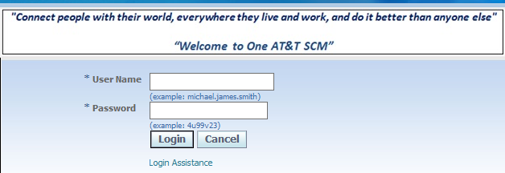

- Select: ATT iSupplier Portal External User– ASN Entry
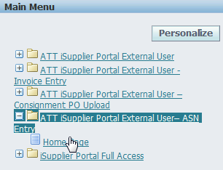

- Under the ‘Shipments’ tab

Under ‘Custom Advanced Shipment Notices
Select the link ‘Upload Advanced Shipment Notices’
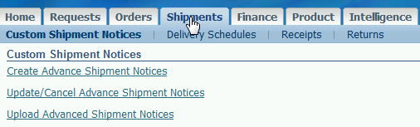

- Select either:
- ‘ASN iSupplier Upload template.xlsm’ link to download a new template (blue arrow, next page). DO NOT Open the template without first saving the template to your PC.
Select the ‘save file’ radio button NOT ‘open with’, followed by “OK”
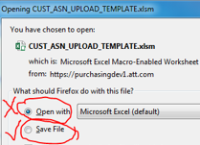

OR, if you have an existing template saved & populated with the new ASN data to upload:

- Select ‘browse’ (red box, next page), search & open your new CSV-formatted ASN file. Enter your email address; additional email addresses can be entered, separated by commas. This will email a copy of the ASN file that you upload to the recipients. Then:
(If an ASN file is not selected, once “SUBMIT” is chosen, this error box will appear):
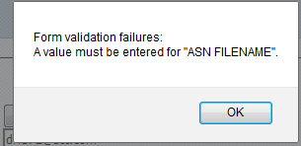

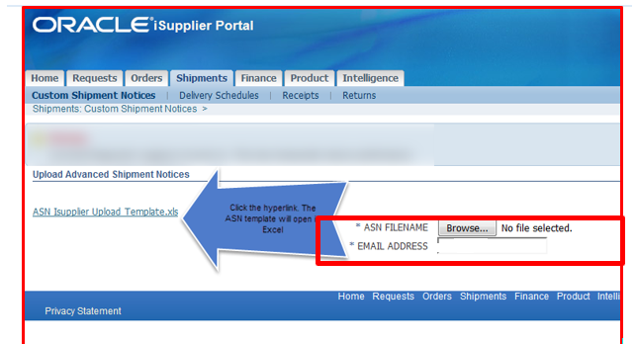
The newly saved ‘ASN iSupplier Upload template’, when opened, will appear as follows:
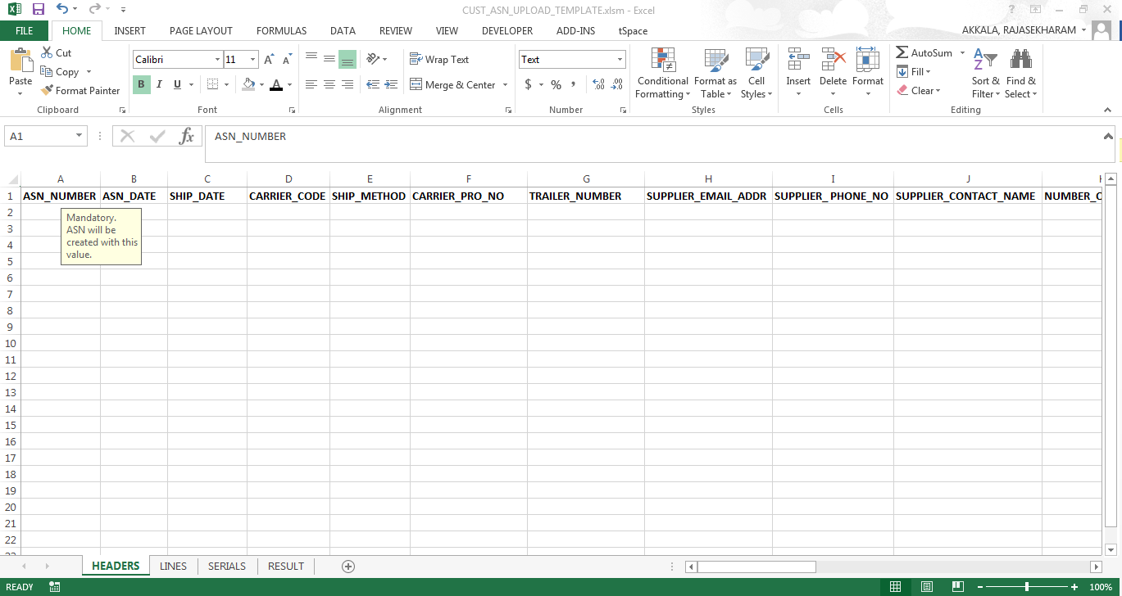

In the toolbar, click on “File” and then select “Options”

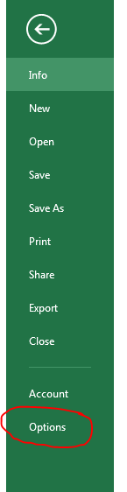
The following should display; select “Trust Center” & “Trust Center Settings”
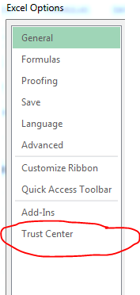

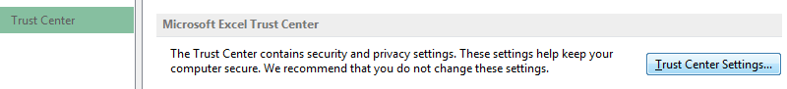

Next, select “macro settings” (left side of screen) and “Enable all macros” as shown below. Also, check the box for “Trust access to the VBA project object model”.

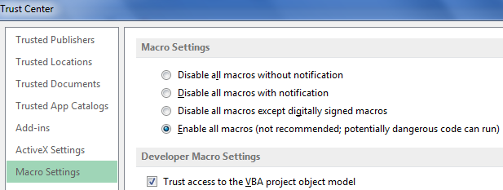

Save your template (File -> Save or Ctrl+S)
Now data can be loaded to the template.

Note the 4 worksheets: Headers, Lines, Serials, Result

- Partial screen capture data of column headers (which extend to column “AG”) - (and examples of values) within ‘Headers’:
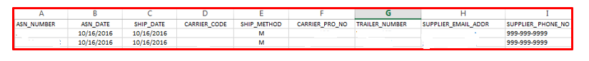

Mandatory fields will be displayed when the cursor is scrolled over the cell, as such:
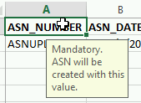

- Partial screen capture of column headers (which extend to column “P”) - with example of values - within ‘Lines’:
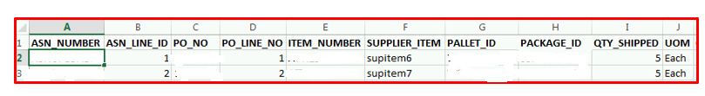

Within the LINES worksheet, enter the ASN Line details under the respective columns.
- Column A: ASN_NUMBER should be entered as the same ASN_NUMBER value from the HEADERS worksheet.
- The ASN_NUMBER to which this line belongs to, that ASN_NUMBER should be entered in LINES sheet.
- Column B: For ASN_LINE_ID, Enter the number “1” for 1st ASN Line for the corresponding ASN_NUMBER. If there are additional line items on the same ASN, then enter “2”, followed by “3”, etc. for lines 2, 3, etc. Additional, unique ASN #s can be entered within this same spreadsheet; however, sequential line ID values (1, 2, etc.) must be entered in this column, associated with each particular ASN #.
- The number which you put in ASN_LINE_ID is VERY important as that decides how many ASN lines you want under that ASN_NUMBER. The same ASN_NUMBER/ASN_LINE_ID combination should be entered against the serial numbers in SERIALS sheet so that all those serials will be created under that ASN number and ASN line combination. If the item is Non-Serialized, then no values need to be populated within the SERIALS worksheet.
- Major criteria in splitting the ASN lines would be the UNIQUE combination of ASN_NUMBER, PO_NUMBER, PO_LINE, PALLET_ID and PACKAGE_ID (Carton).
- ASN_NUMBER: ASN123
- PO_NUMBER: 5678934
- PO_LINE: 1
- PALLET_ID: GHKIJ
- And there are two PACKAGE_IDs (Cartons): CLK1 and CLK2.
- Now the UNIQUE combination of ASN_NUMBER, PO_NUMBER, PO_LINE, PALLET_ID and PACKAGE_ID (Carton) would be as below for
ASN_NUMBER PO_NUMBER PO_LINE PALLET_ID PACKAGE_ID (Carton)
- ASN123 5678934 1 GHKIJ CLK1
- ASN123 5678934 2 GHKIJ CLK2
You should give ASN_LINE_ID as 1 for the combination given in point a). AND
You should give ASN_LINE_ID as 2 for the combination given in point b).

- Partial screen capture the column headers (which extend to column “S”) within ‘Serials’:
If the item #s referenced in column E of the ‘Lines’ screen captured on the previous page were serialized then the ASN serial information would be entered under the respective columns along with the ASN_NUMBER/ASN_LINE_ID from LINES sheets.
This worksheet would remain blank for non-serialized items.
Each ASN should have either all Serialized or Non-Serialized – not combined
Once the data has been entered in all three sheets (HEADERS, LINES, SERIALS) (Ignore the worksheet ‘RESULT’ for now), scroll to your right (following column S) in SERIALS sheet and you will see these two boxes. Click on ‘Here’ within the GREEN button named “PREPARE FOR .CSV FILE”.
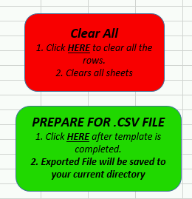
An email will be generated to the user if there any formatting errors within the upload document.

Next, a pop up as captured here will display the file name and the directory where your .csv file has been saved. Click OK.
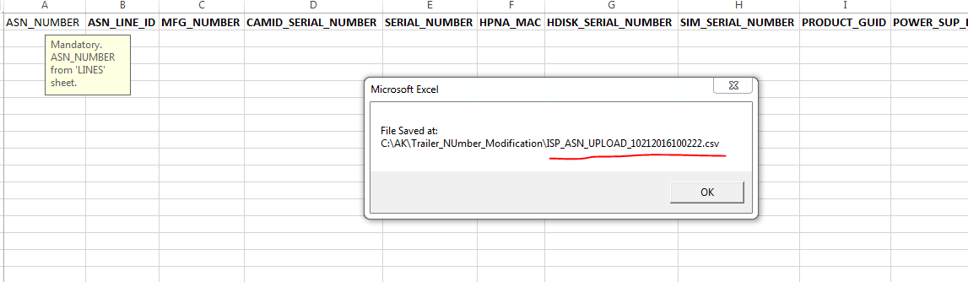

DO NOT CHANGE the file name at any time.
If any modifications are needed, go back to your template and modify the data accordingly and follow click on the ‘GREEN’ button in SERIALS sheet.
A NEW File will be generated again and you MUST use this file to upload, if you feel comfortable with the data. If you feel the data is wrong, you must repeat the process of modifying the data in the template and regenerate a new file.

DO NOT open the .csv in EXCEL.
If you want to cross check the data, you can select OPEN ONLY in a text editor like NOTEPAD, NOTEPAD ++, TEXTPAD etc.
If you OPEN in EXCEL, you will lose all your LEADING ZEROs, if there are any.

If there are any future updates to this template, iSupplier Helpdesk will notify the users to download the new template.

- Following a successful export, the values from the “Headers”, “Lines” & Serials” worksheets will be aggregated within the ‘Results’ tab; example attached

It will be saved in the same directory where the file had previously been opened; however, a new file extension value will be generated, slightly different from the previously saved file (e.g., new: 13381.csv vs. 124512.csv)
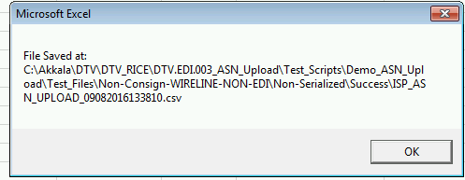

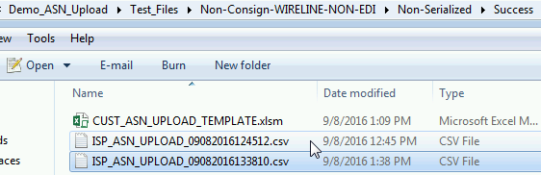

- Next, this newly created .CSV formatted file can be uploaded to iSupplier
Return to home page, select ‘upload ASN’:
Select your saved .CSV file and then ‘submit’ (far right of screen)
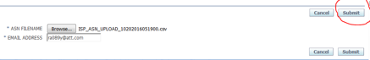
Additional email addresses can be entered, separated by a comma.
This will then navigate the user to the ‘request’ field to see the processing status:
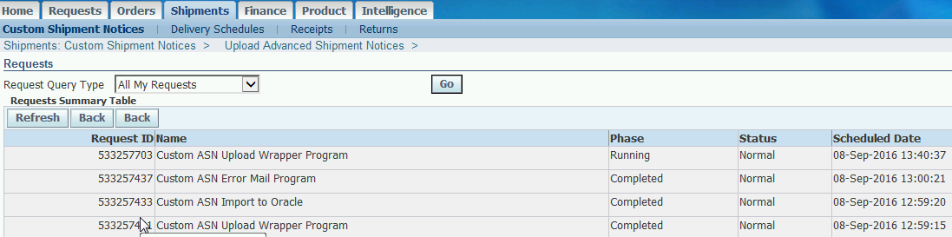

First to run: Upload Wrapper Program
Second: Import into Oracle
Third: Error mail program
“Refresh” can be selected
When the “phase” for all 3 programs is ‘completed’ the ASN has been created
An email will be sent to the user if there are any load or data validation errors detected.
If the user contacts the iSupplier Help Desk, the file name referenced in the error email must be provided.
If an email was not received, click on Output of the concurrent program ‘Custom ASN Error Mail Program’ as shown below.
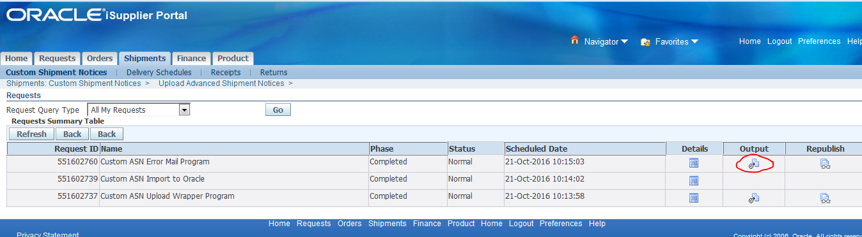
Select either ‘save’ or ‘open with’ ; however, ‘open with’ a TEXT EDITOR line Notepad, Notepad ++, TextPad etc., so that the format of the data will be accurate.
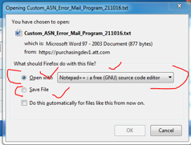
The output will appear as such:
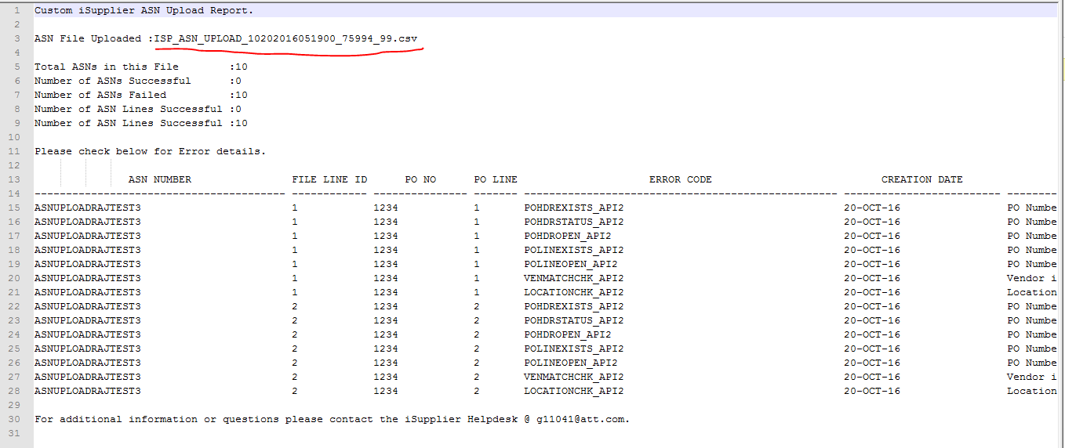

The file name is underlined in red, on the first row above. That file name should be provided to the iSupplier helpdesk person to expedite.
Or, provide the Request id of the concurrent program “Custom ASN Upload Wrapper Program” for the ASN File you have uploaded. The request id, you can find in the Requests page and shown here:
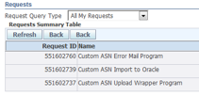

For mandatory fields, refer to the call out boxes in the template.
The file name supplied by the supplier user will be appended by the current logged in user_id and also a unique number generated by the system. Below 816753 is supplier user user_id (Oracle) and 1 is the unique sequence.
Example:
Supplier entered file name – ISN_ASN_UPLOAD_05102016091500.csv
Renamed data file name ISN_ASN_UPLOAD_05102016091500_ 816753_1.csv

An email will be sent to the user (in addition to any other ‘email addresses’ referenced) providing status of the upload; this applies both to successful as well as error-generating uploads. (A validation program is scheduled to run for every hour). One example:
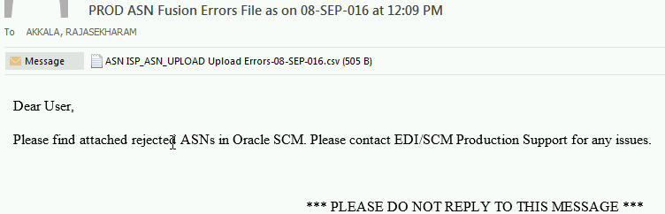
Opening the text attachment within the email will appear something like this (or, right click on the attachment and select ‘open with’ in excel):
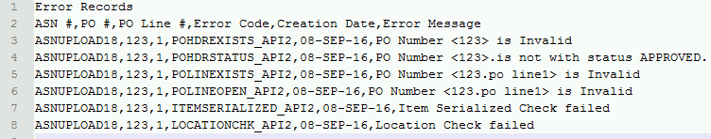

Pease contact the iSupplier Helpdesk via email at g11041@att.com if you need additional information or need assistance.

