iSupplier
Job Aid for “Create Advance Ship Notice (ASN) ”

This job aid details step by step instructions on how a supplier/provider would create an ASN document using AT&T’s iSupplier Portal. ASN data is a highly critical component for supply chain efficiency; without it, scanning, receipting, and validating the contents of a shipment to a warehouse may be delayed or even rejected. Additionally, ASN data provides interested parties the ability to view a ‘promised by’ date to anticipate the arrival of an order at the warehouse.
If you have not yet registered for access to iSupplier, follow these instructions:
Go to the website: http://www.attpurchasing.com.
“iSupplier” (left column) should be highlighted
Select the ‘User Setup Request Form’ and complete the required fields and submit
An email notification will subsequently be sent to you, providing your ‘user name’ and ‘password’ values to log into iSupplier. Contact the iSupplier Helpdesk at g11041@att.com with any questions.

    - Login to the iSupplier Portal via: https://scmpurchasing.att.com
    - Enter your assigned ‘user name’ and ‘password’
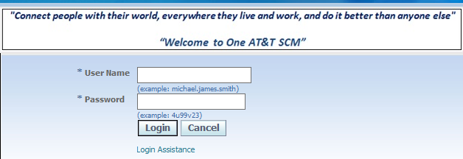

    - Select: ATT iSupplier Portal External User– ASN Entry
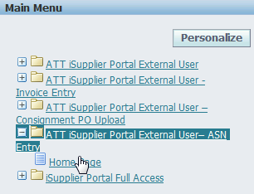

    - Under the ‘Shipments’ tab
Under ‘Custom Shipment Notices
Select the link ‘Create Advance Shipment Notices’
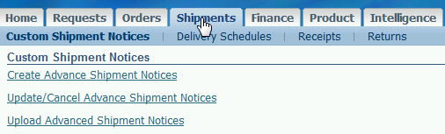

    - Input a value in: PO #, Ship to location, or any other field, then “Search”

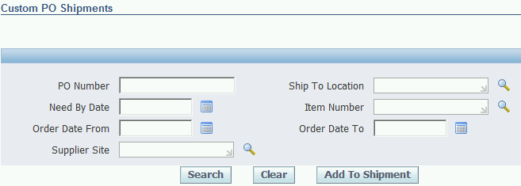

    - Results will display at the bottom of the page (PO # in left column)
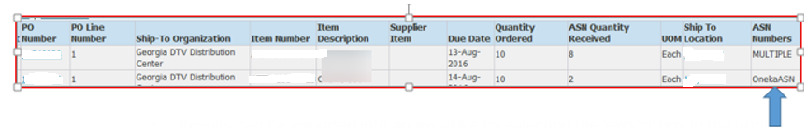
Results can be exported by selecting the ‘export’ box in the upper right corner (the default is a .csv format; to then save the .csv file in excel format: File > Select ‘all files’ > Open > Text Import Wizard > click ‘delimited’ > next > click ‘comma’ > finish > save file as .xlsx ; open in excel for easier viewing)
    - In the ‘ASN Numbers’ column (far right), values can be either ‘Multiple’ or ‘OnekaASN’; this indicates that a PO has either one ASN or multiple ASNs associated with it; If a PO line item contains serialized items, the ‘serial control’ indicator will appear as “Y” (as seen below):

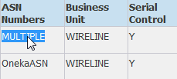
The following PO lines cannot be combined into a single ASN:
- Serialized & non-serialized items
- PO #s associated with different Business units (i.e Wireline, Wireless)
- PO #s with 2 different ship-to locations
Once ‘add to shipment’ is selected, an error such as the following could result:
Note that hyperlinks under both the PO # as well as the ship-to location can be selected
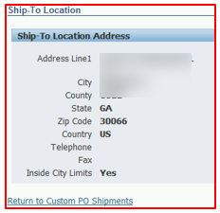
Two (or more) POs with the same ship-to location can be checked (first column) & then ‘add to shipment’
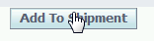
‘Shipment Lines’ tab is the default view (partial view, top of page):
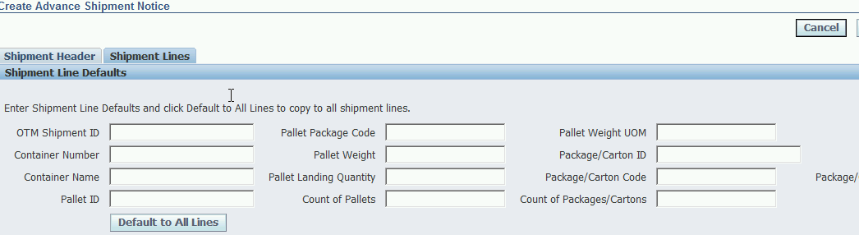

If any of the values associated with the fields above apply to all the POs that you’ve selected, you can enter the values and then select the ‘default to all lines’ box (thereby reducing duplication of manual entries); example on next page
Bottom of page:
…. Here are the 2 PO#s that were selected above
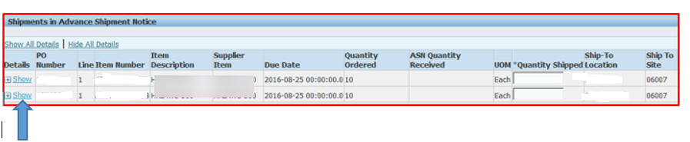

When you click on ‘Show’ or + the PO to ‘show all details’, the ‘default to all lines’ entries will appear as such (partial view):
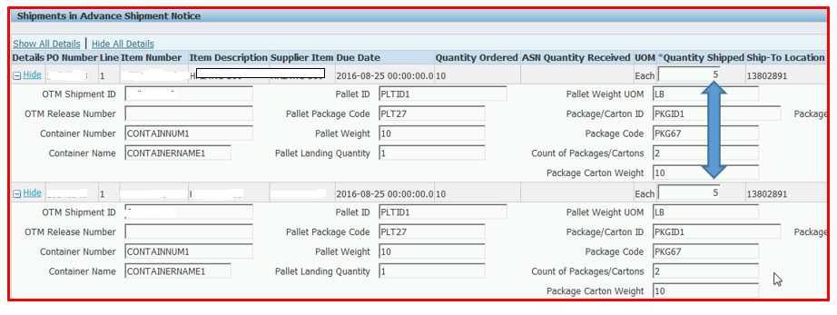

The ‘quantity shipped’ field is flagged as ‘mandatory’ (other fields may follow) and must be entered individually
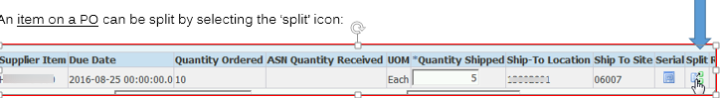
This would duplicate the existing line item (in the process removing the former quantity value; in this case, “5”) and add another line; the user would then enters the quantity in each of the new ‘quantity shipped’ fields (partial view):
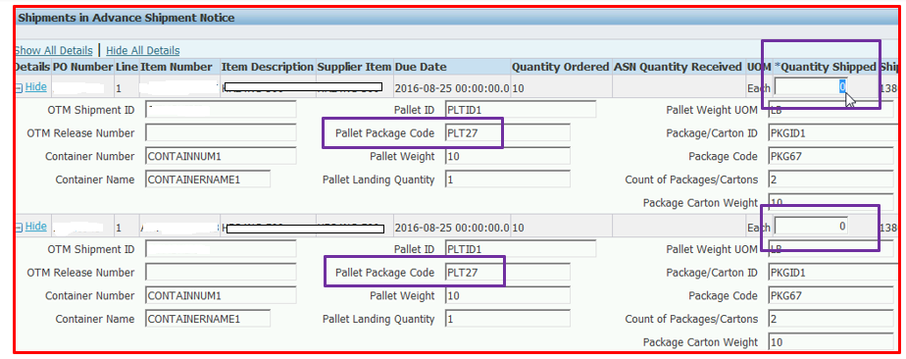

This split may be selected to differentiate unique ‘package/carton ID’ (e.g., PKGID1 & PKGID2) or ‘package code’, or any other value that may differ between the two.
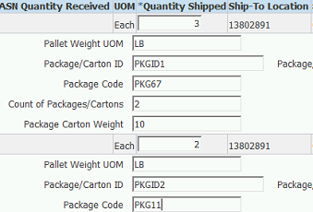

Serial data values can be input by selecting the ‘serial’ icon, applying to each individual line item: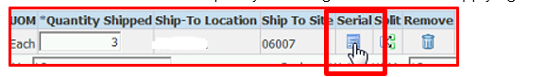
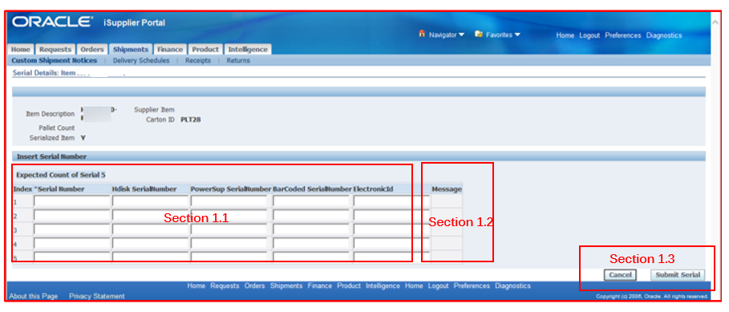
- Section 1.1
This section will display all the serial types setup for a given item, based on serial types that exist in the value set compared to the ITEM catalog for that item.
- Section 1.2
This section will display validation error messages if the validations API throws error message after the user clicks on the Submit serial. If there is more than one error message, it will show all the messages ‘;’ separated.
- Section 1.3
This section has two buttons:
Cancel: This button when clicked will take the user to the Shipment Lines page again.
Submit: Clicking on this button will run the validation API and show the errors in the message section of each line. If no errors, users will get an successfully submitted message. The serials will eventualy be submitted into the data base only if the ASN Valdiations go through fine and gets submitted.
If an API validation error occurs, it will prevent the creation of the ASN. Select ‘Cancel’ and correct the error before proceeding
Select ‘submit serial’
If no errors, select “submit ASN”; this message validates the creation of the ASN:
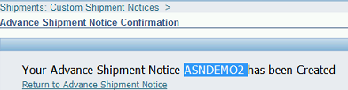
Here is how the fields within the ‘Shipment Header’ tab appear:
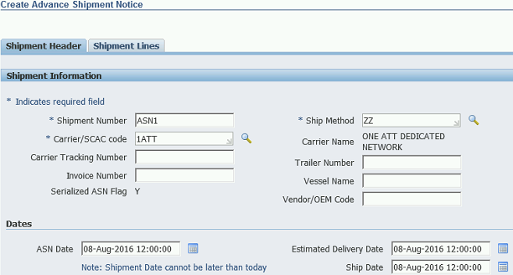

Use the ‘magnifying glass’ for a drop down menu of values

Bottom of page:
Auto-populates based on ship-to # of the PO (but the supplier can override the default values)
