iSupplier
Job Aid for “Acknowledging a Purchase Orders (PO)”

NOTE: PO Acknowledgment is currently only available for RETAIL DEVICE Suppliers/OEMs.
This job aid details step by step instructions on how a supplier will use the AT&T iSupplier Portal to acknowledge an Oracle Purchase Order (PO). AT&T will request acknowledgment of the purchase order. You will receive a summary email notification once daily of all the POs that have been created that day that require your response. Upon receiving the summary email notification, you will need to login to the AT&T iSupplier Portal to acknowledge the Purchase orders by choosing “Accept” or “Reject”. Additionally, you have the option to include a “Note to the Buyer” if you are “Accepting entire Order. This is not required unless you choose to “Rejecting Entire Order”. After Accepting or Rejecting the PO, the PO is automatically updated, and an email is sent to the Buyer/Planner. Note: You will only be allowed to “Accept the entire Order” or “Reject the entire Order”.
Note: If your company sends an EDI 855, the need to manually acknowledge is not necessary; however, you will continue to receive the email regardless of how you receive the PO (PDF or EDI).
To acknowledge purchase orders:
    - Login to the iSupplier Portal via: https://scmpurchasing.att.com
    - Enter your assigned ‘user name’ and ‘password’
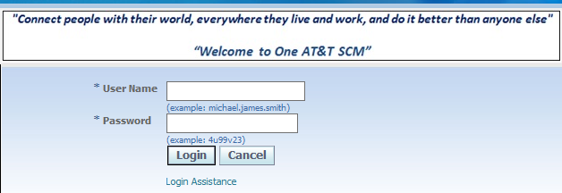

    - Select: ATT iSupplier Portal External User– Invoice Entry
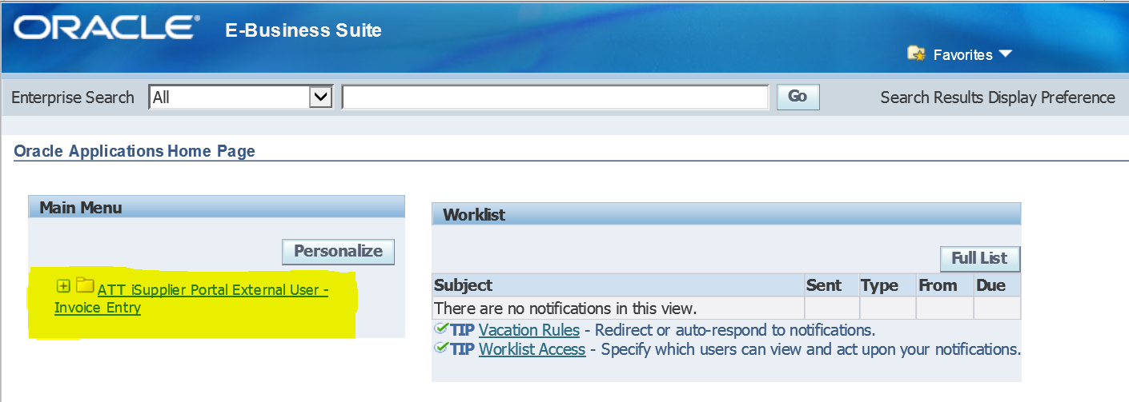

Under the ‘Orders’ tab
Under ‘Purchase Orders
Select ‘Purchase Orders to Acknowledge’ from the View dropdown & “GO”
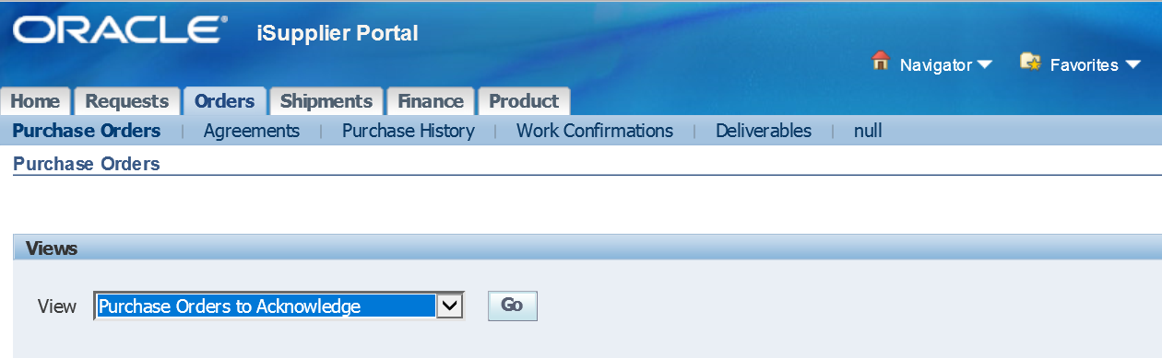

    - Select the radial button to the left of the PO#(s) that you need to acknowledge, then click the “Acknowledge” button

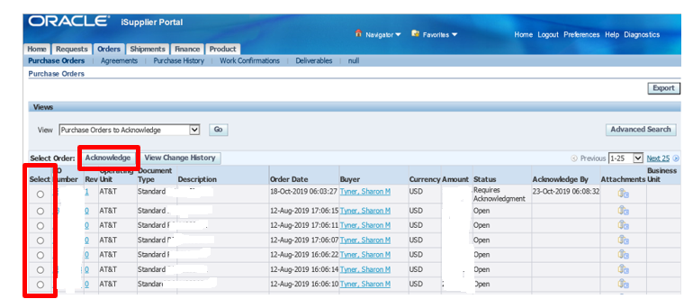

    - Once the PO has been selected, the PO will display and give you the following options to choose from.
      - Cancel
      - Reject Entire Order
      - Accept Entire Order
      - View Change History
      - Export

    - Upon selecting, “Accept Entire Order”, you have the option to include a “Note to the Buyer”. This is not required unless you choose to “Rejecting Entire Order”.
    - Then click the “Submit” button

    - Once submitted, you will receive an PO Acknowledgment Confirmation. Simultaneously, the PO is automatically updated, and an email is sent to the Buyer/Planner.

- If you have question regarding your PO, why you must acknowledge the PO, etc. please contact your Buyer and/or Planner.
- If you have questions/issues regarding iSupplier functionality, login issues, password resets, etc. please send an email to the iSupplier Helpdesk @ g11041@att.com

